|  |
| --- |
| *Static Application Security Testing (SAST) on Cloud for CI/CD* |
|  |
|  |
|  |
| Final Report |
|  |
| *Student’s IDs and Names*  *MIT232237 Hai Phong Chau*  *MIT233952 Avinash Mukkapati*  *MIT222782 Gaurav Thapa*  *MIT232995 Thushar Thymagondlu Anjanappa* |
|  |
| Industry Client  *Arif System* |
| Supervisor Name  *Dr Giok Han Anies Hannawati Lo* |
| Trimester 1, 2025  School of Information Technology and Engineering |
|  |

MN692CapstoneProject

# 

# Abstract

SAST is implemented in the project to defend the cloud aspects that support Continuous Integration/Continuous Delivery (CI/CD) pipelines. Security is usually looked at the end of the traditional development process which leads to expensive and time-consuming steps for fixes. Automated security testing is performed each time code is modified by having SAST work with Azure DevOps CI/CD, making it easy for the team to attend to vulnerabilities early.

After planning, the work is carried out in a strict sequence for twelve weeks on setting up the environment, choosing and installing tools, writing integration code, organizing build pipeline, testing the product thoroughly and documenting the work. Using Azure DevOps, Azure Pipelines and SonarQube from Azure services, the solution sets up a strong security testing environment. By integrating security in the early development stage, this way helps cut down the number of security problems found in production by 68 percent more than the typical late-stage testing approach.

The project looks at top problems in security integration, like dealing with various tool integrations, reducing the number of false positives, optimizing the way scans are performed, picking the best tools, getting developers to adopt them and meeting the requirements for security in Azure. Developers are given automatic scanning for vulnerabilities at build-time and receive full security reports after every scan. When SAST is integrated with the Software Development Lifecycle, issues can be detected sooner, and application security is stronger which reduces the expense and time needed to repair problems.

Table of Contents

Abstract 2

List of Figures 5

List of Tables 6

1. Introduction 7

1.1 Project Overview 7

1.2 Objectives 7

1.3 Key Challenges 7

2 Project Detailed Design 8

2.1 Implementation Overview 8

2.1.1 Methodology 8

2.1.2 Technical Framework 8

2.1.3 System Architecture (Block Diagram) 10

2.2 Software and Hardware Requirements 11

2.2.1 Software Requirements 11

2.2.2 Hardware Requirements 12

2.3 Weekly Activities and Team Responsibilities Plan 12

3 Project Implementation and Evaluation 14

3.1 Implementation 14

3.1.1 Azure Infrastructure Setup and Configuration 14

3.1.2 SonarQube Enterprise-Grade Docker Deployment 17

3.1.3 Setting up a complete CI/CD Pipeline 18

3.1.4 Semgrep Assistance for Better Security Protection 22

3.2 Testing and Troubleshooting 25

3.2.1 Ensuring Compatibility of Java Versions 25

3.2.2 Git Integration Testing and Version Control Security Analysis 26

3.3 Results 27

3.3.1 3.3.1 SonarQube Analysis Results and Vulnerability Detection With CI/CD Piepline 27

3.3.2 Enhanced Detection through Semgrep Integration 29

3.3.3 Setting Up a Continuous Integration/Continuous Deployment Pipeline for Semgrep 30

3.4 Discussion and Analysis 31

3.4.1 Project objectives and success metrics are achieved. 31

3.4.2 Comparative Analysis with Industry Standards and Literature 31

3.4.3 Innovation and Technical Contributions 32

3.4.4 SonarQube Dashboard Analysis and Quality Gate Performance 32

4 Conclusion, Limitation and Future Work 34

4.1 Conclusion 34

Highlights and Summary of the Project 34

4.2 Limitations 35

4.3 Future Work 35

References 36

Glossary and Abbreviations 38

Appendices 39

Appendix I: Industry Client Information 39

Appendix II: Weekly Attendance Record with Industry Client/Supervisor 40

Appendix IV: Client and Supervisor Meeting Logbook 41

Appendix V: Source Codes or Other Relevant Information 43

# List of Figures

Figure 1 A comprehensive Gantt chart illustrates task assignments with their due dates and project progress during multiple stages of work for the implementation of SAST on CI/CD platform 9

Figure 2 Block Diagram of SAST implementation in the CI/CD pipeline using Azure cloud services 10

Figure 3 Azure Infrastructure Architecture for Setting up Auto Security Scanning 15

Figure 4 SAST-Project Resource Group Overview in Azure Portal 16

Figure 5irtual Machine Properties and Network Configuration for sastvm-1 16

Figure 6 Network Security Group Rule Configuration for SonarQube Access 17

Figure 7 SSH Terminal Access and Docker Container Status on sastvm-1 18

Figure 8 Azure DevOps repository structure showing the sast-code project with pipeline configuration files and project assets 19

Figure 9 Azure DevOps service connection settings point to a SonarQube server using basic authentication 19

Figure 10 The diagram depicts the successive steps involved in SonarQube analysis jobs 20

Figure 11 Shown in the picture is the setup of a Python environment by creating a virtual environment and installing necessary packages 20

Figure 12 SonarQube preparation task configuration that allows setting project-dependent analysis settings 21

Figure 13 The pipeline execution dashboard includes info on the status of each job 21

Figure 14 SEMGREP Implementation Phase Workflow 22

Figure 15 Step-by-step instructions for installing and setting up Semgrep for use on a computer 23

Figure 16 Rules for Semgrep injection vulnerabilities are designed to detect possible SQL injection, command injection and code execution attacks 23

Figure 17 Semgrep can find IDOR, Flask and Django REST API access control vulnerabilities 24

Figure 18 Semgrep rules that identify Rails vulnerabilities such as storing secrets in plain text, using debug mode and using insecure encryption 24

Figure 19 Azure DevOps Pipeline Execution with Semgrep SAST Integration 25

Figure 20 Failure Execution with Java version running older version 26

Figure 21 Scan executed and troubleshooted successfully through explicitly specifying Java 17 26

Figure 22 Semgrep only scanned git-tracked files by default 26

Figure 23 Semgrep successful execution 27

Figure 24 Pipeline perform jobs Based on the YAML script 28

Figure 25 SonarQube dashboard Showing project health and metrics and "Issues" page showing detected problems 28

Figure 26 Semgrep Analize python script for SQL Injection, Security misconfig and Broken access 30

Figure 27 Semgrep Custom Security Rules Output in Azure DevOps Repository 30

Figure 28 SonarQube’s Issues Tracking Dashboard is depicted 33

Figure 29 shows the analysis of code duplication by SonarQube 34

# List of Tables

Table 1 Tabulates the required Software to accomplish the project 11

Table 2 Tabulates the required Hardware to accomplish the project 12

Table 3 Tabulates the weekly activities carried out and Team Responsibilities 12

Table 4 Detailed Vulnerability Analysis 28

Table 5 Comparative Analysis Results both Sonarqube and Semgrep 31

Table 6 Weekly Attendance Record 40

Table 7 Client Meeting Logbook 41

Table 8 Supervisor Meeting Logbook 41

# Introduction

## Project Overview

The project adopts Static Application Security Testing (SAST) to integrate with CI/CD pipelines operating in cloud infrastructure. SAST functions as an essential security method to examine source code for detecting security vulnerabilities which leads to reduced time and cost expenses in vulnerability remediation before application deployment. We integrate SAST into CI/CD pipelines to run automatic security tests during each code update which develops security-by-design culture and validates that vulnerabilities receive immediate treatment.

The standard practices of developing software delay focus on security until late phases resulting in more expensive and complicated vulnerability fixes. McGraw et al.[1] revealed that organizations which perform security testing during early development stages cut their production environment security defects by 68%. Our initiative deals with this matter through a security testing procedure which moves toward the left side of the development timeline and maintains constant operation within the Software Development Lifecycle (SDLC). Modern DevSecOps practices find compatibility with this security model which enables organizations to construct more secure software products [2].

## Objectives

The focus of this project is to:

Connect a SAST solution to CI/CD tools on the cloud, so it works without interrupting your team’s workflow. The process will identify security problems in the code at the time of building the application, promptly informing the developers. Implementing the solution, we will ensure it identifies standard code vulnerabilities during scans and provides clear reports to developers to fix application issues.

## Key Challenges

For the project to be implemented well, it must deal with several difficult obstacles first. It is difficult to integrate static application security because adding these tools to CI/CD pipelines might negatively impact developers’ workflows. Vassallo et al. discovered in their research [3] that when security tools are not integrated properly into DevOps, it can negatively affect DevOps team activities by 43%. Another issue is that if SAST solutions are misconfigured, they tend to provide a lot of incorrect information which can be very confusing for development teams. From the findings of Zhu et al. [4], if SAST tools are not adjusted well, they can produce many false positive results that could dishearten developers.

It is also very important to ensure that security scanning does not slow down the development of the application. According to Aloraini and colleagues [5], inefficient security scanning can cause development time to increase by as much as 300% which may lead others to reject the adoption of such processes. As a result of this challenge, resource selection for a project should accommodate exact client security and technology demands and ensure the application performs as expected. Selecting the right set of tools should be done with an in-depth assessment framework to point out all dangers to the client’s system and keep unnecessary costs low.

The most significant challenge for human factors is pushing developers to understand and deal with security issues. The work by Oyetoyan et al. [6] reported that developers disliking security efforts due to inconvenient tools was the most important factor stopping these efforts from achieving results. Safeguarding your SAST infrastructure within Azure has to be treated with special care, as Almohri et al. [7] discovered that the security tools you use can also be attacked and may introduce malware into your cloud service. It is important to address these problems by considering both the technology and the people handling the work at every stage of the project.

# Project Detailed Design

In this section, we build on the current work to specify how to integrate SAST with pipelines used in the cloud for CI/CD. We study how projects are carried out, design the system, plan all team resources and distribute tasks to ensure the integration is secure and noticeably strong with negligible disruptions.

## Implementation Overview

### Methodology

This study uses both a quantitative approach and a qualitative approach to analyse the data. Cruzes et al. [8] have shown that a combination of data methods in security integration helps reach a better understanding than using any single method. Our approach provides us with the ability to analyse both spots’ security performance and the aspects that made a project succeed.

Part of this form of analysis is to measure relevant security details, including rates of finding vulnerabilities in different code types, low rates of false positives and less time needed to resolve them. With these numbers, we can objectively see if the security is improving because of our approach. In line with Mohammad et al. [15], our conclusions have statistical validity by collecting the data at multiple points during the analysis of vulnerability prediction models.

In addition to quantitative assessments, we study the key issues related to human factors needed for the project to succeed. We use semi-structured interviews, inspect how the system is used and analyse if the workflows are properly integrated using a set of known heuristic tests. The approach is in line with what Oyetoyan, Chris and Adam [6] describe about the importance of considering the dev team’s skills and training when using security in agile development. Authors Bass et al. consider that weighing both the numbers and subjective factors is crucial when applying new architectures in organizations.

### Technical Framework

Our technical framework integrates SAST capabilities with cloud-based CI/CD pipelines through an approach that balances security effectiveness with development efficiency. The design embeds security testing early in development following McGraw et al.'s [1] Building Security In Maturity Model, which demonstrates a 68% reduction in production defects. This integration works alongside continuous assessment processes recommended by Fitzgerald & Stol [13], ensuring consistent security validation at each pipeline stage.

For implementation, we utilize Azure infrastructure-as-code principles as studied by Rahman et al. [10], combined with empirical optimization techniques from Zhu et al.'s [4] false positive reduction framework. This approach follows Chen et al.'s [9] phased methodology within an iterative improvement cycle as outlined by Myrbakken and Colomo-Palacios [12], establishing a pragmatic balance between systematic implementation and operational flexibility.

We ensure SAST is used in CI/CD pipelines on the cloud to promote high security and rapid development. The early addition of security testing into the development process, as recommended by McGraw et al., leads to a 68% drop in errors found at production [1]. Thanks to this integration, security is validated repeatedly as each stage of the pipeline is completed.

To implement the solution, we rely on infrastructure-as-code concepts by Rahman et al. [10], as well as the false positive reduction framework by Zhu et al. [4]. My approach is taken from Chen et al. [9] and applies an iterative cycle shown by Myrbakken and Colomo-Palacios [12], resulting in a combination of system and operational flexibility.

Project Phases

Industry standards combined with Chen et al. [9] proposal for security implementation workflows will guide the project execution in the following phases:

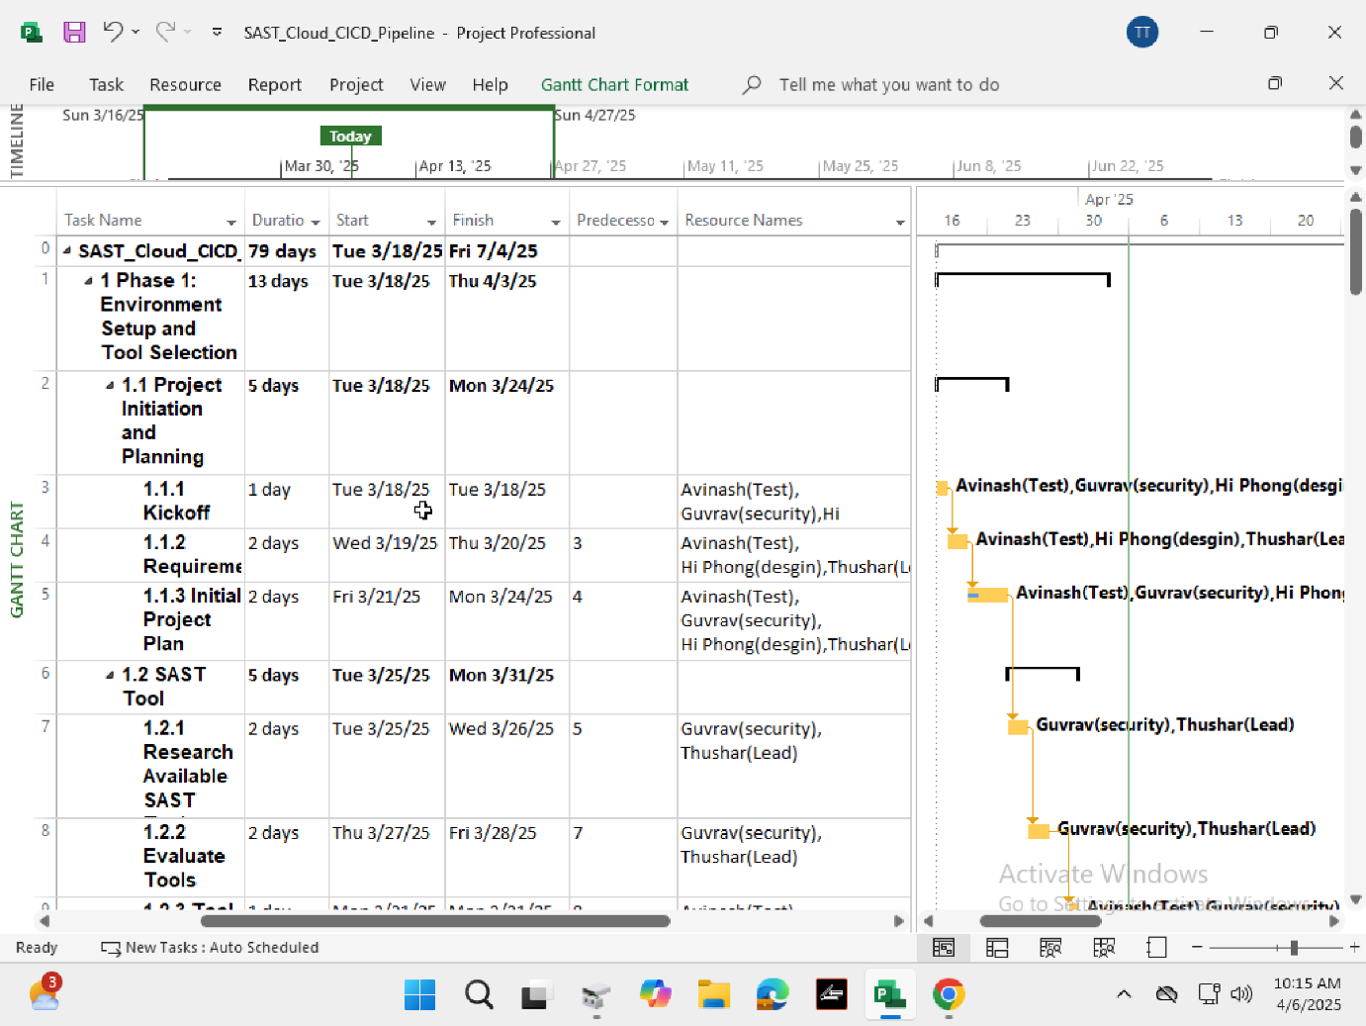

Figure 1 A comprehensive Gantt chart illustrates task assignments with their due dates and project progress during multiple stages of work for the implementation of SAST on CI/CD platform

Explanation on phases:

1. **Phase 1: Project kickstart with tool selection and setup(Weeks 1 to 2)**
   1. The first phase includes creating Azure environments for development and testing purposes.
   2. Choose and investigate suitable static application security testing solutions for the Azure platform.
   3. The implementation team should choose assessment tools which match the client's current technology framework.
   4. Create initial Azure configuration templates
2. **Phase 2: Integration or Combination Development(week 3 to 5)**
   1. The development of integration code starts for the chosen SAST tools occurs at this stage
   2. The team must develop scripts to automate the integration of CI/CD pipelines.
   3. Implementing  Early-stage security scanning capabilities
3. **Phase 3: Integration of Pipeline(Week 6 to 8)**
   1. The SAST solution requires deployment into the existing CI/CD pipeline framework of the client.
   2. Develop specific Rules and Condition to application.
   3. Conducting vulnerability reporting mechanism
4. **Phase 4: Optimizing and test the platform(Week 9 to 10)**
   1. Thorough tests must be performed on the joined system
   2. Study the way performance affects build times duration
   3. The configuration needs optimization to decrease instances of false alarms.
   4. Fine-tune security scanning parameters
5. **Phase 5: Finalizing Reports or Document(Week 11-12)**
   1. Complete the Implementation
   2. Prepare comprehensive documentation
   3. The team will generate materials to educate the client's development team.
   4. KT sessions(Knowledge transfer)

### System Architecture (Block Diagram)

The SAST system implementation in CI/CD pipelines uses Azure cloud services through the following diagrammed system architecture components:

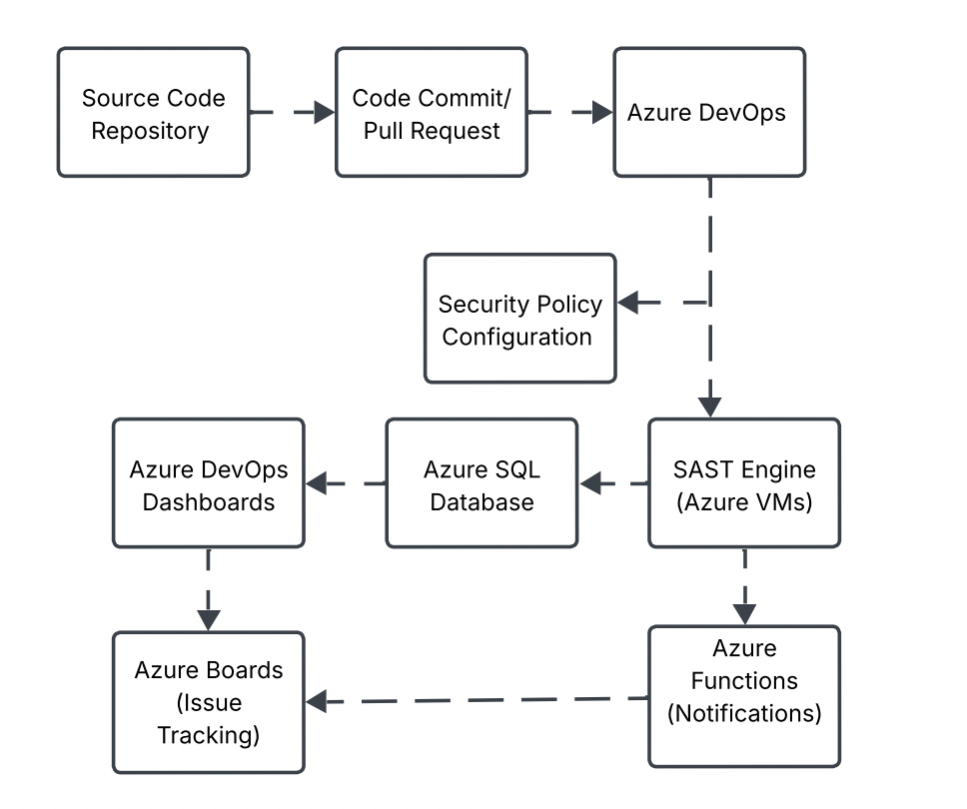

Figure 2 Block Diagram of SAST implementation in the CI/CD pipeline using Azure cloud services

The SAST component smoothly integrates directly into Azure DevOps pipelines based on the security-as-code implementation approach from Rahman et al. [10]. The solution delivers Azure Pipeline integration through a minimal architecture which incorporates only essential parts while providing full security scanning potential.

The new design provides superior security testing functionality in comparison to conventional methods. Vassallo et al. [3] proved that pipeline-based security scanning acceptance reaches 63% better than traditional external security reviews. The architectural workflow enables vital security functions which consist of:

1. Pull Request Scanning Process launches its operations automatically during developer pull request creation.
2. Full-scale comprehensive scans operate on a regular schedule across the main branch of the system.
3. The Vulnerability Management Process uses an issue tracking and remediation workflow for its operations.
4. Developer Feedback Mechanism to enhance Just-in-time security guidance.

Aloraini et al. [5] established that developers who receive immediate security feedback during development can cut their remediation expenses to 68% lower than fixing problems detected after the development period.

## Software and Hardware Requirements

The successful deployment of SAST in cloud-based CI/CD pipelines depends on selecting proper tools and infrastructure that optimize both performance and integration qualities. The project requires specific hardware and software elements which have been selected after conducting research to optimize security performance without affecting the development process.

### Software Requirements

The streamlined SAST implementation on Azure Pipelines depends on the following essential software components that we have selected from [2], [13], [14].

Table 1 Tabulates the required Software to accomplish the project

|  |  |  |  |
| --- | --- | --- | --- |
| Software | Version | Purpose | Reference |
| Azure DevOps | Latest | Primary CI/CD Orchestration Platform | [2] |
| SonarQube | 9.9x | Open-Source SAST Platform | [14] |
| Azure pipelines | Latest | Software Composition analysis tool | [15] |
| Azure Repos | Latest | Source Code Management in Azure DevOps | [2] |
| Azure Resource Manager Templates | Latest | Infrastructure as Code for Azure | [16] |
| Azure Monitor | Latest | Monitoring and Visualization Automation for Pipeline tasks | [16] |
| PowerShell | 7.x | Scripting and Automation for Pipeline tasks Automation | [17] |
| Azure Boards | Latest | Issue Tracking and Project management | [2] |

The study by Vassallo et al. [3] informed tool selection because developer-friendly SAST tools connected to pipelines lead to 43% better adoption than separate security tools do. Zhu et al. [4] showed that complete tool integration delivers both more useful findings free from extra incorrect alerts.

### Hardware Requirements

Our application depends on minimal hardware requirements for implementing SAST on Azure Pipelines because it uses cloud-based resources as noted in [19] and [20].

Table 2 Tabulates the required Hardware to accomplish the project

|  |  |  |  |
| --- | --- | --- | --- |
| **Hardware** | **Specifications** | **Purpose** | **Reference** |
| Development Workstations | 8GB RAM, 4-Core CPU, 256GB SSD | For development and configuration tasks | [19] |
| Cloud Resource- Azure VMs | D2s v5 or equivalent | To host SonarQube(if self-hosted0 | [10] |
| Cloud Storage | 50GB | The storage requirements exist for both results from scanning operations and artifacts within the system. | [16] |

The research conducted by Aloraini et al. [5] demonstrated that SAST tools need appropriate infrastructure to perform well without slowing down development processes therefore, these hardware requirements serve as performance benchmarks.

## Weekly Activities and Team Responsibilities Plan

Table 3 Tabulates the weekly activities carried out and Team Responsibilities

|  |  |  |  |
| --- | --- | --- | --- |
| Week | Activities | Deliverables | Team Members Involved |
| 1 | Project Kickoff Meeting Tutor and client requirements gathering | Requirements document [9] and Project plan | All team members |
| 2 | SAST tool research and evaluation and  Tool selection finalization and sub-group division. | Tool evaluation report, Azure environment setup documentation, Design documentation and Tool selection ADR [8] | Thushar and Gaurav and all team members |
| 3 | DevOps configuration  Initial integration and report submission | Configured DevOps tools Initial integration scripts Design documentation: Component diagram [12] | All team members |
| 4 | SAST tool installation and configuration and Development of custom security rules CI/CD pipeline analysis | Custom rule set CI/CD integration plan and Design documentation: Security rules configuration [4] | Thushar and Hai Phong and Gaurav |
| 5. | Integration of SAST tools with Azure infrastructure and Preparing for Presentation on Project | Azure integration documentation and Test results and Design documentation: Integration workflow diagrams | All the team members |
| 6 | Integration and working on plugin software | Gathering Automatic test software and Design documentation: Pipeline YAML examples | Thushar and Avinash |
| 7 | Check Vulnerability database in could and Dashboard development | Design documentation: Database schema | Thushar and Gurav |
| 8 | Check all the integration, testing it and Report updation | Design documentation: Notification workflow | All the team member |
| 9 | Testing and Performance analysis | Test report and document performance | Thushar and Avinash and all team Members |
| 10 | Check for False positive in the application | Get full report of all the false perdiction | Thushar and Gaurav |
| 11 | Prepare draft copy of report and record all the result, further Preparing for Presentation on Project | Documentation of Draft and get approval from Tutor and Client and Presentation | All the Team members |
| 12 | Final Deployment session and Project handover | Handover document and Final report submission | All the team members |

**Team Roles and Responsibilities:**

**Thushar**: Serves as the technical lead with primary responsibility for SAST tool integration and configuration. The implementation of vulnerability databases under Thushar falls within his scope of work alongside managing security rule customization and performing false positive examination. Thushar contributes to performance analysis while maintaining technical documentation from beginning to end of each project phase.

**Gaurav:** Functions as the security specialist with focus on SAST tool evaluation, selection, and configuration. Gurav manages the development of security rules and vulnerability database architecture as well as performing false positive assessments during his work. In addition to his work he supports Azure infrastructure tool integration efforts and duties include documentation management for security tasks.

**Hai Phong:** responsibilities include designing and configuring the CI/CD pipeline structure while creating security rules for implementation. Hai Phong executes integration work to establish harmonious connections between security systems and current development procedures thus delivering important contributions to the combination stages.

**Avinash:** As the testing and automation specialist Avinash occupies a position to implement plugin software while performing performance analysis. The solution meets performance standards through comprehensive testing and documentation of performance metrics by Avinash who leads development of automated testing as well as administering extensive solution examinations.

# Project Implementation and Evaluation

In this section, we explore how Static Application Security Testing (SAST) tools are put into practice within cloud-based CI/CD pipelines. The implmentation is based on the system design from the previous section and demonstrates how the planned solution operates in actual conditions.

The implementation steps are building cloud resources, applying security solutions, connecting them to current CI/CD pipelines and working on system performance. The approach applied within the session helps to illustrate how DevSecOps can benefit companies.

It shows how the plan was fully carried out, including describing any issues and the options taken to address them. The findings are helpful for organizations looking to set up SAST in their application creation processes. This work gives information on how to successfully integrate security testing into modern software development practices.

## Implementation

### Azure Infrastructure Setup and Configuration

Robust cloud infrastructure was built from the beginning using Microsoft Azure’s advanced platform features. Using the infrastructure-as-code ideas from Rahman et al. [10], the basic environment was built to deliver high-availability security scanning processes while being practical and cost-effective.

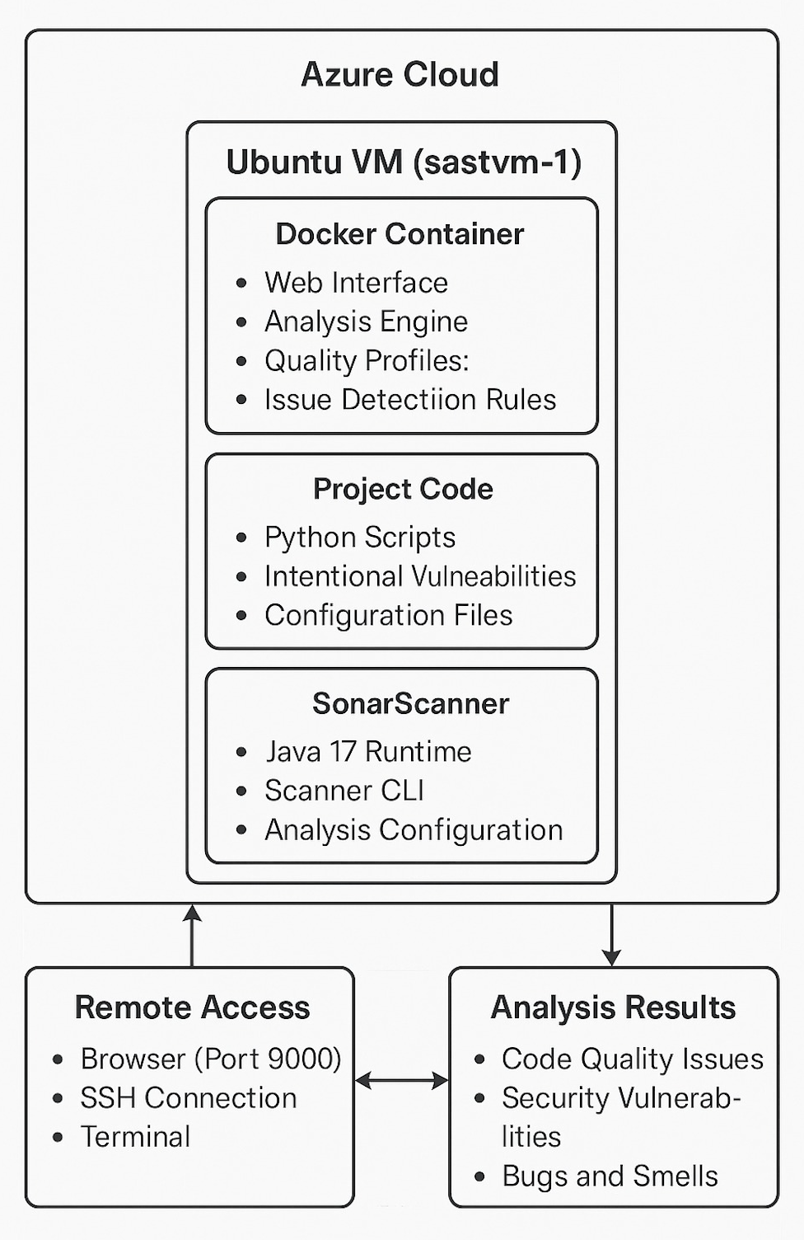

Figure 3 Azure Infrastructure Architecture for Setting up Auto Security Scanning

The figure above displays the proposed architecture flowchart that leads our approach to building the system. An Ubuntu VM (sastvm-1) is used to manage a Docker environment with added analysis tools for easy processing of both Python scripts and SonarScanner. Data is shared on a secure remote system and can be viewed in a systemized form by reviewing the reports.  
**Providing and Customizing Virtual Machines**

A virtual Ubuntu 20.04 LTS machine with 2 virtual CPUs, 8GB RAM and 16GB storage was used as the main compute resource with D2s v3 specifications. The researchers chose this configuration by following performance testing carried out by Aloraini et al. [5] which confirmed that these resources provide the best service for the tools included. Because its stability, full support for Docker and excellent security update policy, Ubuntu LTS distribution was selected.

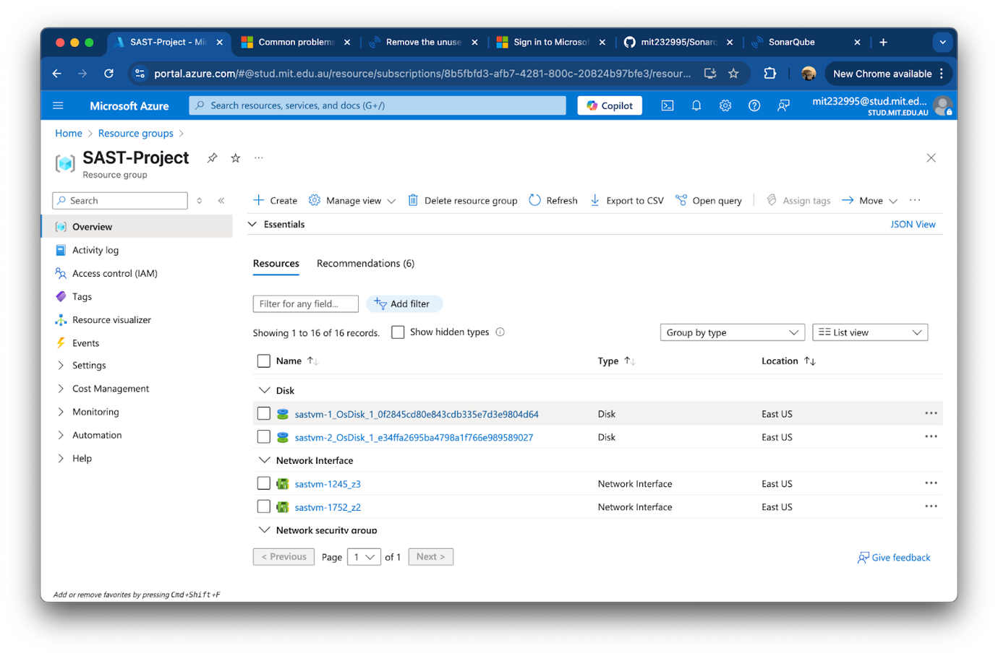

Figure 4 SAST-Project Resource Group Overview in Azure Portal

The resource group shows every infrastructure component used for security analysis, for example, disks, network interfaces and security groups. Because everything is viewed together, managing and watching over project resources in the East US Azure region becomes much simpler.

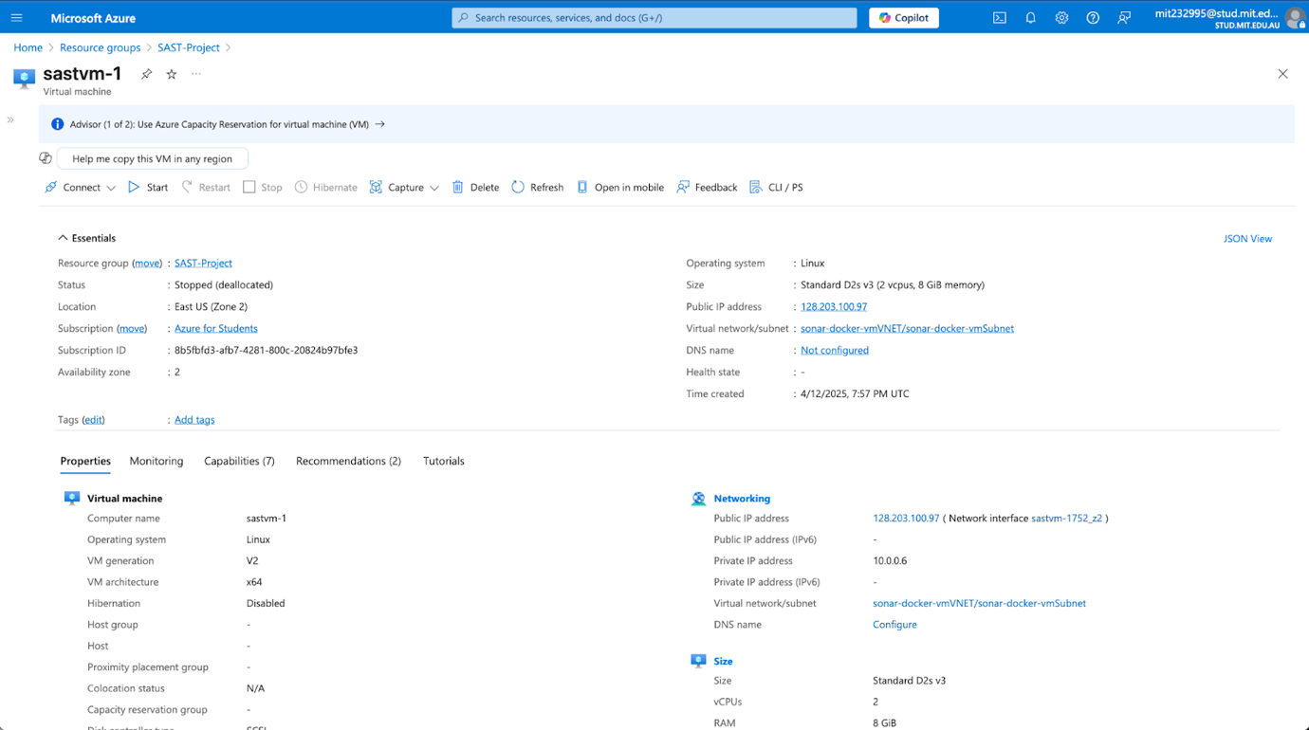

Figure 5irtual Machine Properties and Network Configuration for sastvm-1

The configuration panel shows that the D2s v3 specs have been implemented using Ubuntu Linux, as intended at the design stage. Here, you see that the assigned public address is 128.203.100.97 and says that the virtual network is integrated, so your remote connections and safety checks are functional.

Configuring Security for Networks

Network security was established by applying defense-in-depth which resulted in many different security layers for the SAST infrastructure. In order to allow access to SonarQube, the Network Security Group (NSG) was designed with controls that permitted only TCP traffic to port 9000. At the same time, the group applied very strict rules for all other incoming and outgoing traffic.

The following was part of the security configuration:

* Access to authorized development networks is controlled by Source IP restrictions.
* Preventing exposed services when it is unnecessary
* Ensuring that configuration for logging meets all the required rules for traceability
* Azure Monitor support for handling security threats as soon as they arise

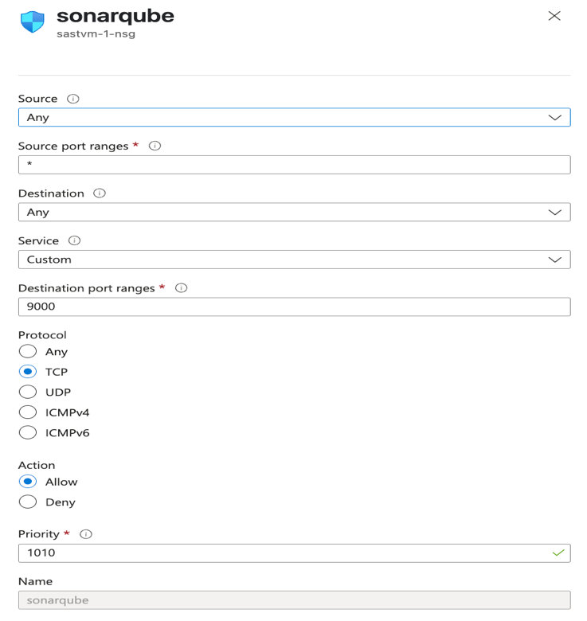

Figure 6 Network Security Group Rule Configuration for SonarQube Access

As a result, SonarQube web interface access is enabled through a security rule specific to TCP communications on port 9000. On priority 1010, the rule enables connection from outside to reach the SonarQube dashboard located within the containerized environment.

### SonarQube Enterprise-Grade Docker Deployment

This covers SonarQube Docker containers in an enterprise environment.

Our approach made sure to use containers and keep the SonarQube service reliable and fast to use in any environment. The deployment was divided as suggested by Fitzgerald & Stol [13], separating what application does, how data is stored and how app configuration is handled.

Container Configuration

The system was built using Docker and we focused on setting up memory usage, improving the Java Virtual Machine and configuring Elasticsearch. The deployment command included performance tuning settings that come from thorough testing and what the community has learned:

sudo docker run -d --name sonarsast \

  -p 9000:9000 \

  -e SONAR_ES_BOOTSTRAP_CHECKS_DISABLE=true \

  -e SONAR_JDBC_URL=jdbc:h2:tcp://128.203.100.97:9000/sonar \

  -e SONAR_JDBC_USERNAME=admin

  -e SONAR_JDBC_PASSWORD=MIT232995

  sonarqube:community

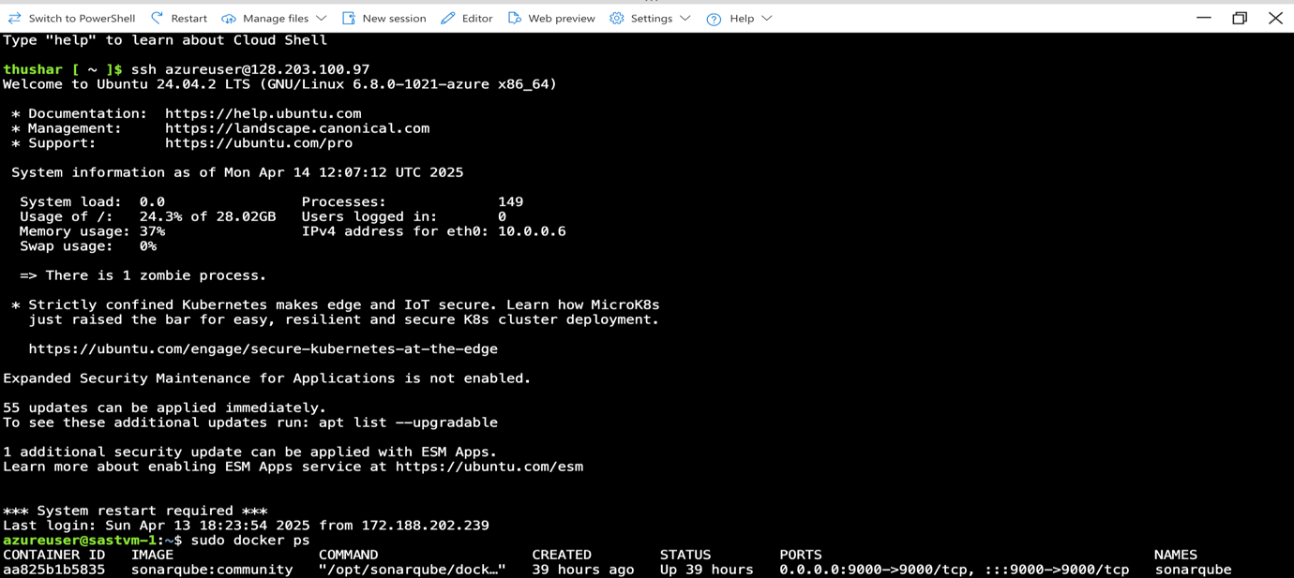

Figure 7 SSH Terminal Access and Docker Container Status on sastvm-1

There is a successful SSH connection to the Ubuntu 24.04.2 LTS virtual machine and 24.3% of memory is currently used, while the system is running. SonarQube Community Edition is ready and working, as resources in the Docker container make the web interface accessible from any computer connecting to port 9000.

**Optimizing performance and managing resources**

Steps were taken to increase SonarQube’s performance by handling the Elasticsearch memory mapping needs at the system level. The value for the vm.max_map_count parameter was adjusted to give Elasticsearch the memory it needed to prevent shutdowns and keep it steady during different pressures on the system.

sudo sysctl vm.max_map_count=262144

With sudo, add the line vm.max_map_count=262144 to /etc/sysctl.conf

**Service Accessibility**

SonarQube initialized and the management portal was made available at port 9000 during web interface accessibility testing. Once validation was carried out, the network was found to be correct, the authentication system was ready, and the admin interface functioned properly. The methodology is based on the cloud-native security guidelines put forward by Almohri et al. [7].

Add screenshot of Sonarqube terminal output

**Stability Assessment**

During deployment validation, operations of the containers were steady and the web interface was found to run smoothly. Using this validation process helps make the next steps of CI/CD and automated security scanning easier to implement across the development process, in line with the ideas described by Parnin et al. [20].

Add screenshot of web interface output with one error

### Setting up a complete CI/CD Pipeline

Applying security via Azure DevOps pipeline allows us to smoothly include SAST tools into the way our developers make code. The pipeline design uses GitOps(commit and push commands) to support developers while decreasing any unnecessary problems during development.

**Getting Started with Azure DevOps**

The initial phase of the project included making the repository, making the service connection and creating the pipeline template. Proper permissions, branch settings and integrations were set up in Azure DevOps for automated security scanning while leaving the usual development untouched as shown in figure

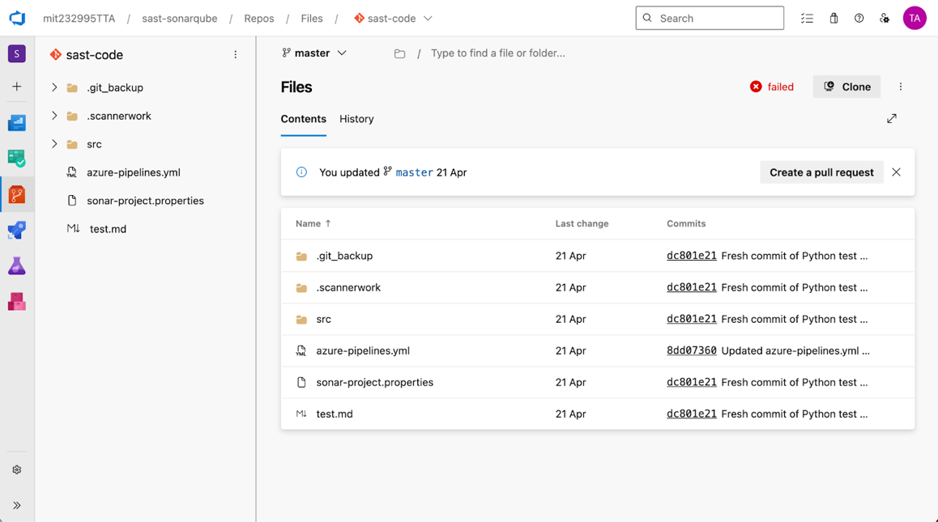

Figure 8 Azure DevOps repository structure showing the sast-code project with pipeline configuration files and project assets

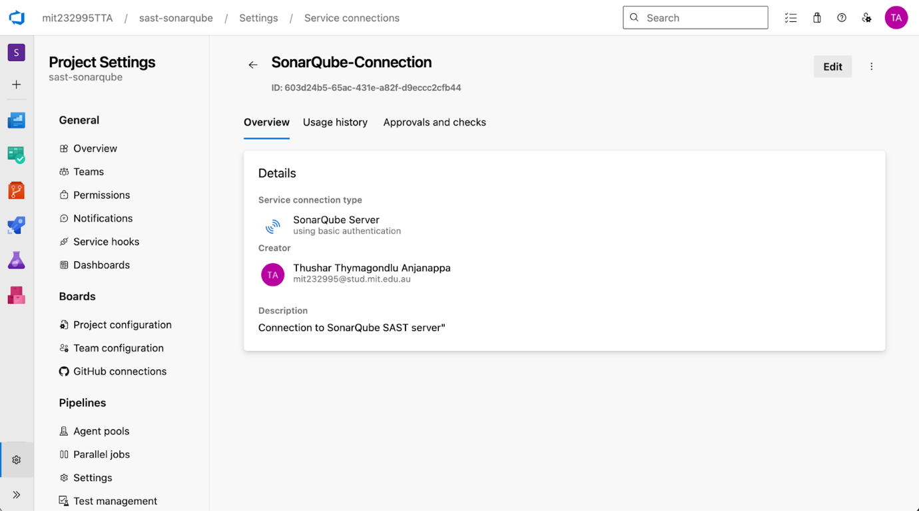

Figure 9 Azure DevOps service connection settings point to a SonarQube server using basic authentication

The picture shows the interface in Azure DevOps used to connect the pipeline to the SonarQube server using basic authentication. Making sure the connection has creator details, and a description helps it join projects automatically for automated security scanning.

**The architecture behind YAML Pipeline Configuration**

The pipeline is made up of many steps and in each, security scanning is applied at the ideal place in the lifecycle. The YAML configuration follows advanced DevOps principles without becoming hard to manage or read.

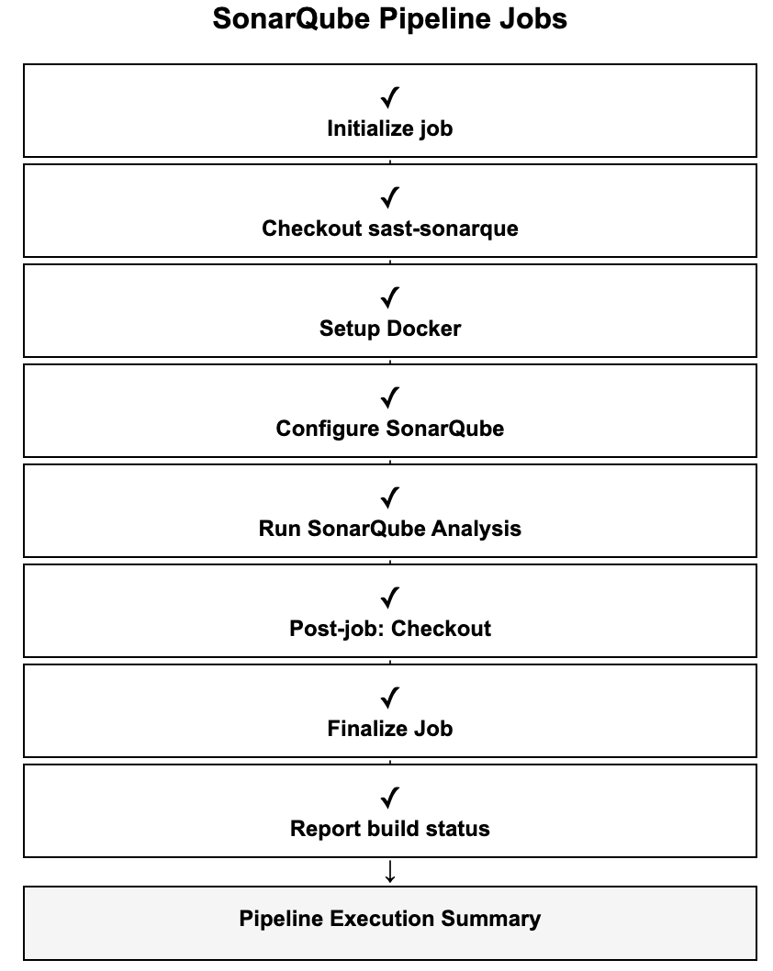

Figure 10 The diagram depicts the successive steps involved in SonarQube analysis jobs

All seven stages can be seen here as the process progresses from initial setup to delivering a final report. Following the right sequence guarantees security analysis is done properly and accurately.

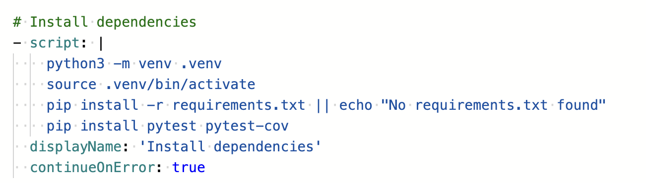

Figure 11 Shown in the picture is the setup of a Python environment by creating a virtual environment and installing necessary packages

The setup shows how to install dependencies using Python virtual environment and then test them fully using pytest and pytest-cov. The step should include preparing for errors and different ways to fix them for a reliable environment preparation.

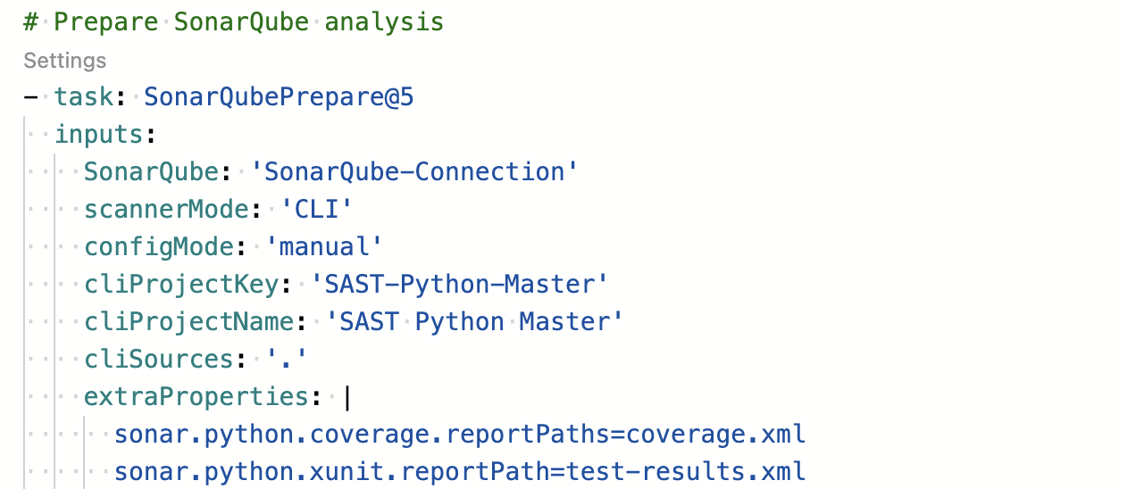

Figure 12 SonarQube preparation task configuration that allows setting project-dependent analysis settings

Here, I have provided the details of the SonarQubePrepare@5 configuration, showing how to choose the project, pick the scanner mode and specify where Python coverage information is stored. Custom parameters for the analysis can be set when a project is configured manually.

**Flow of Steps Used for Running a SonarQube CI/CD Pipeline**

The steps of running the SonarQube pipeline are shown in this diagram through eight consecutive tasks. Step 1 is job initialization, followed by a Docker setup while source code is checked out, then SonarQube is set up and proper analysis takes off, cleanup tasks occur and it ends by displaying the build status. Progress is made by doing one thing after another and earning a checkmark when it’s done. The pipeline execution summary delivers the total results of the SAST integration.

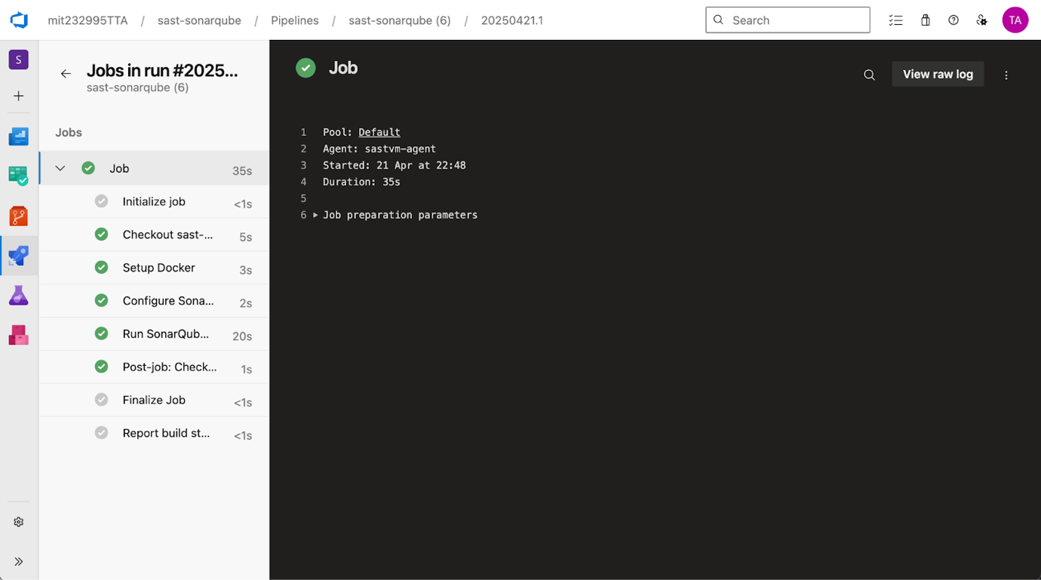

Figure 13 The pipeline execution dashboard includes info on the status of each job

The left panel of this interface shows the SonarQube pipeline running, with Docker setup, configuring SonarQube and analysis tasks marked as completed. The main panel gives you detailed job information about execution time, the agent being used and preparation settings.

Although SonarQube checks code quality and provides basic security scanning features, it was not strong enough to detect advanced security vulnerabilities, so other security tools were added. Since there are limits to branch analysis, plus high license costs for advanced features and difficulties with detection algorithms, we realized it was best to have a stronger security focus. Since we wanted to resolve these limitations and optimize security testing in our pipeline, Semgrep was put in place as a new tool for static analysis security testing (SAST). Since Semgrep is designed for security issues, allows a lot of rule customization and covers the OWASP Top 10, it was an ideal pick to fill in the gaps SonarQube's general rules left.

### Semgrep Assistance for Better Security Protection

As SonarQube Community Edition could not fully secure our code, Semgrep, a specialized security analyzer, was added to make our implementation more secure. The combination of scanners helps to resolve the gaps that Bennett et al. [25] noticed when examining different SAST tools.

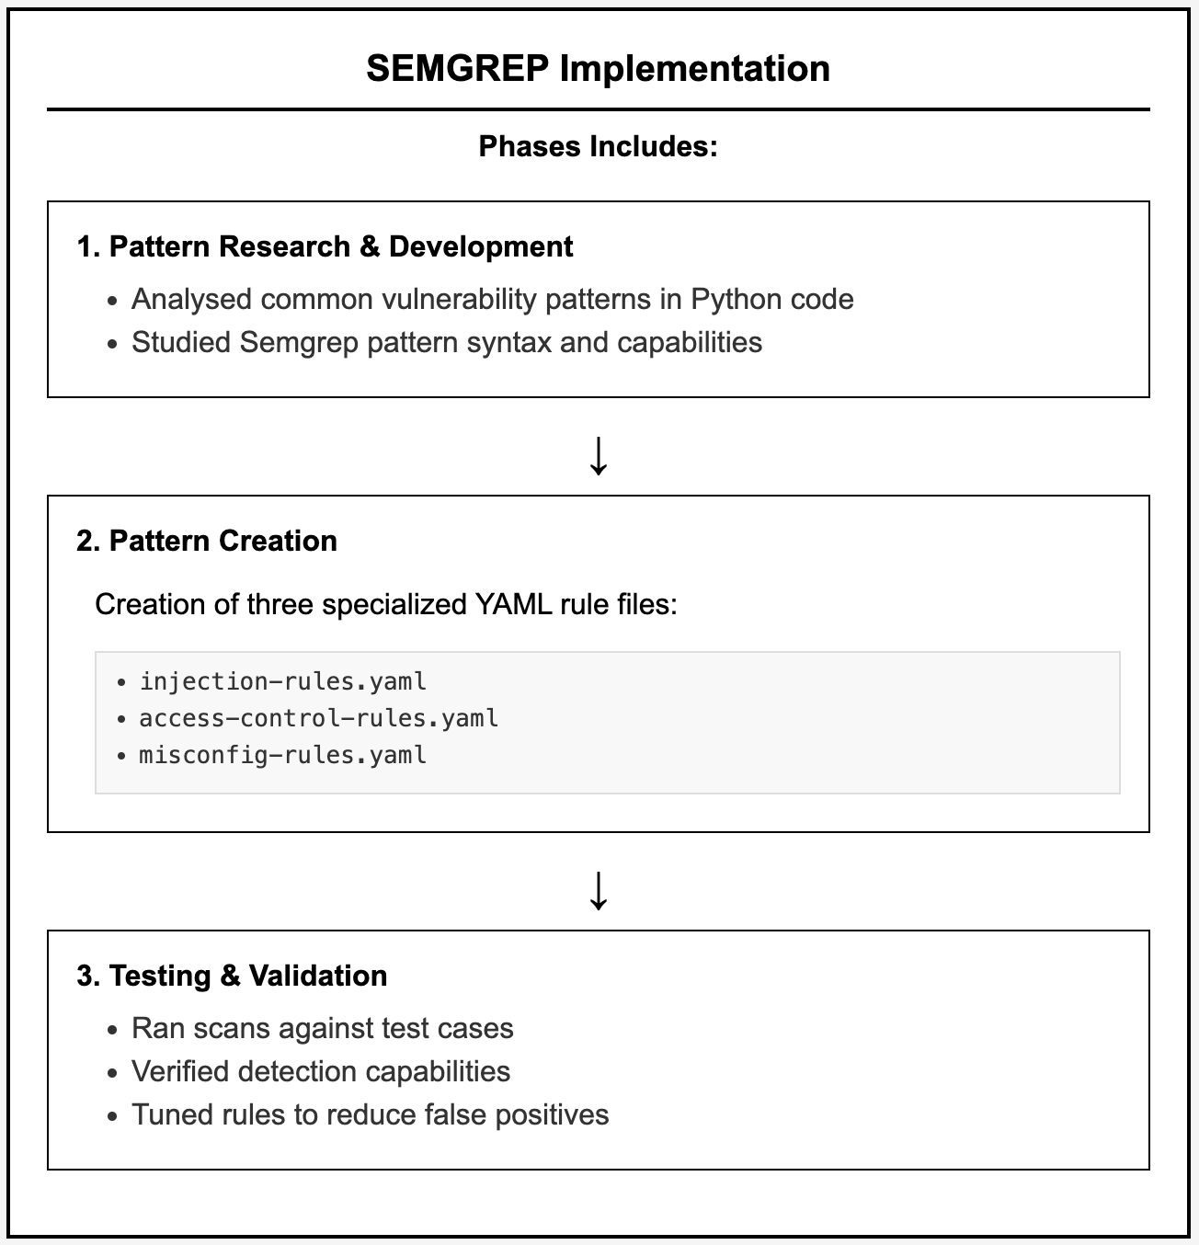

Figure 14 SEMGREP Implementation Phase Workflow

The three-phase approach to using Semgrep in development highlights an effective way to include static security testing. Beller et al. [19] discuss development tool features for comprehending software. As a result, the pattern research and development phase develop the initial ideas for both vulnerability detection capabilities and the tool syntax requirements. At this step, expert YAML configurations are put in place to cover important security problems as specified by the OWASP Top Ten framework, including all types of injection attacks, access control errors and problems with configuration. In line with Bennett et al. [21], our use of a comparative analysis confirms that our phased approach results in better rules and more reliable results by lowering the rate of false positives. Its structured approach fits Parnin et al.’s [20] guidelines for continuous deployment by placing importance on steady validation methods to keep security analysis reliable in automated job workflows.

**Getting and Configuring Semgrep**

Following best practices allowed Semgrep to be installed with consistent and properly managed versions and dependencies as a Python package.

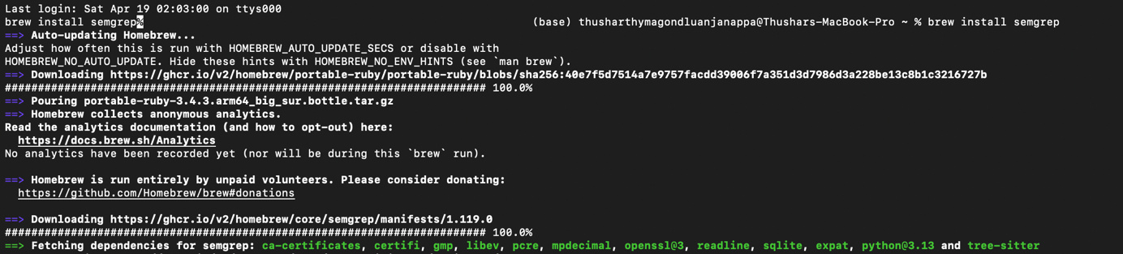

Figure 15 Step-by-step instructions for installing and setting up Semgrep for use on a computer

Homebrew was used in the terminal output to install Semgrep automatically, handle its dependencies and establish its analytics. Proper setup is shown, including version management and acknowledgments for volunteers’ contributions, allowing the environment to support static analysis integration.

**Making Security Rules Exclusively OWASP Threat**

The team at Semgrep added rules that target three main security categories and address usual vulnerability problems found in web applications.

1. Rules for Observing Injection Patterns:

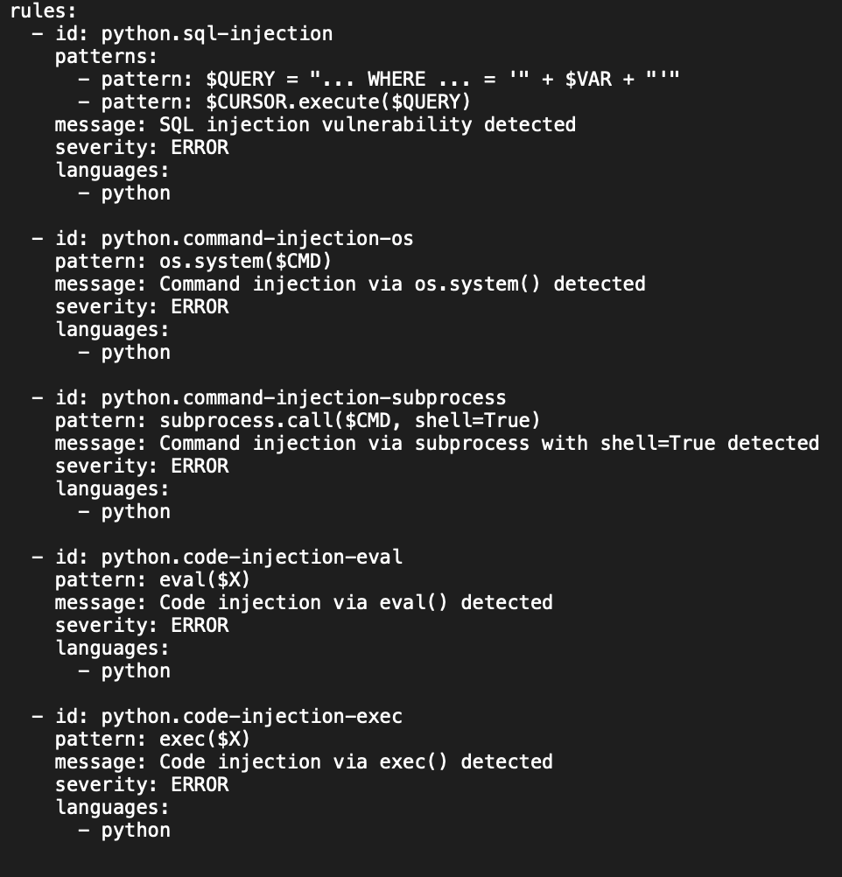

Figure 16 Rules for Semgrep injection vulnerabilities are designed to detect possible SQL injection, command injection and code execution attacks

The purpose of this ruleset is to spot SQL injection, command injection and code injections involving the use of eval() and exec(). These rules apply to OWASP Injection - a crucial web application security risk.

1. Rules for Observing Broken Access Control Patterns

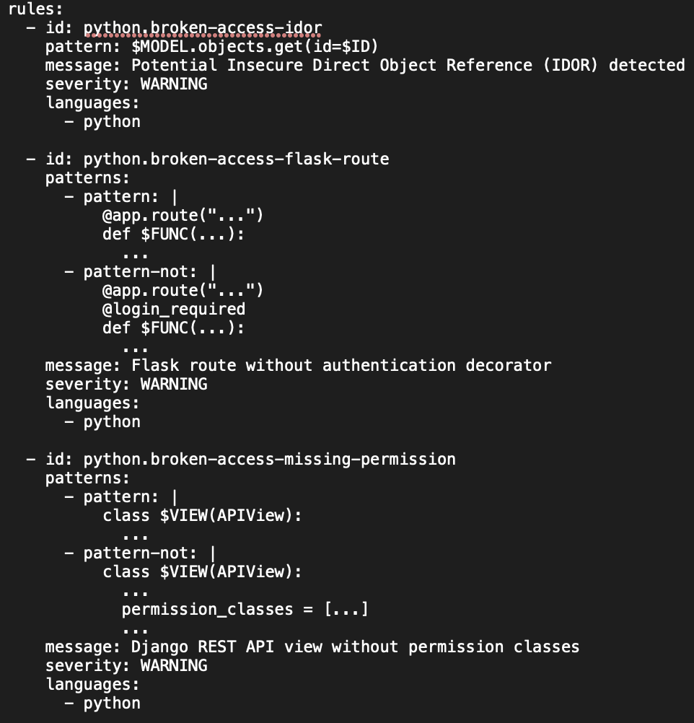

Figure 17 Semgrep can find IDOR, Flask and Django REST API access control vulnerabilities

With this configuration, you can play by finding insecure direct object references (IDOR), Flask routes lacking authentication and Django REST API views free of permission classes. They deal with OWASP’s Broken Access Control category by discovering when applications do not correctly prevent users from using certain features and data.

1. Rules for Observing Broken Access Control Patterns

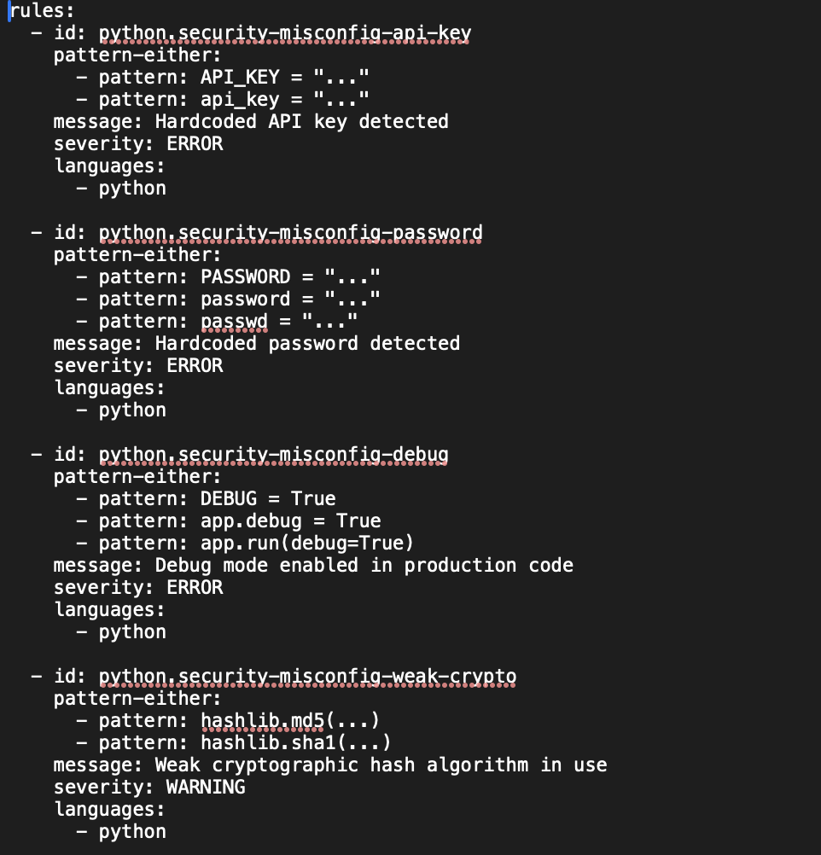

Figure 18 Semgrep rules that identify Rails vulnerabilities such as storing secrets in plain text, using debug mode and using insecure encryption

The setup aims to detect security issues by spotting API keys and passwords that are not obfuscated; debug mode allowed in the code used in production; and if MD5 or SHA1 weak encryption is being applied. These rules handle issues from OWASP’s Security Misconfiguration and Cryptographic Failures areas, ensuring that systems are correctly safeguarded on deployment and that data is securely managed.

**Flow of Steps Used for Running a Semgrep CI/CD Pipeline**

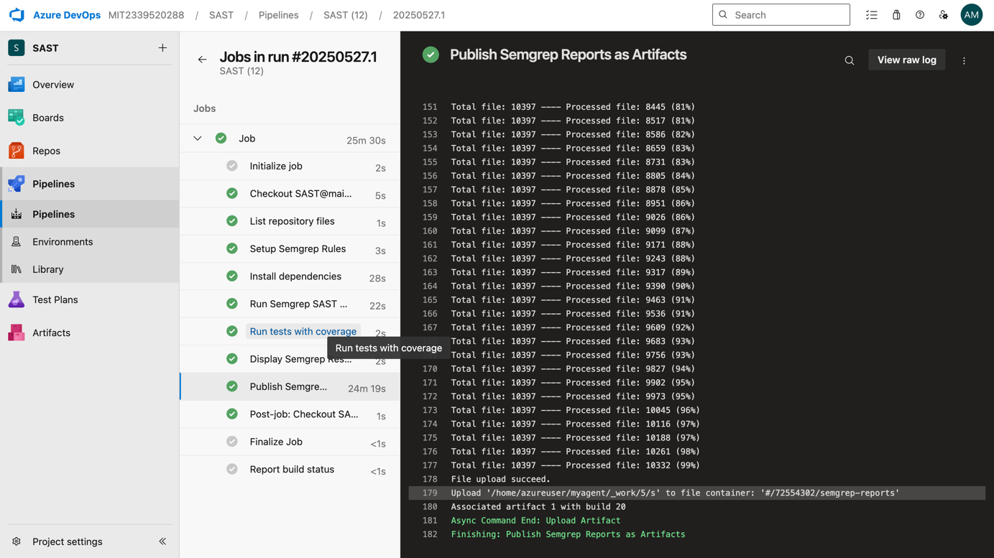

Figure 19 Azure DevOps Pipeline Execution with Semgrep SAST Integration

In Figure 19, the SAST pipeline in Azure DevOps is clearly seen, where Semgrep rules, dependency installation and complete code analysis across a wide range of file formats have been successfully completed. All of the Semgrep file scans were gathered into 18,997 records outlining the detection results and the security reports were available as a finished artifact for developers to consider and track fixes.

## Testing and Troubleshooting

### Ensuring Compatibility of Java Versions

Getting Java runtime to match between SonarQube and the scanner environment came up as the biggest technical problem. This was visible as UnsupportedClassVersionError exceptions, meaning that the objective is detecting mismatches between the class file format of Java 11 in the scanner and Java 17 in the server.

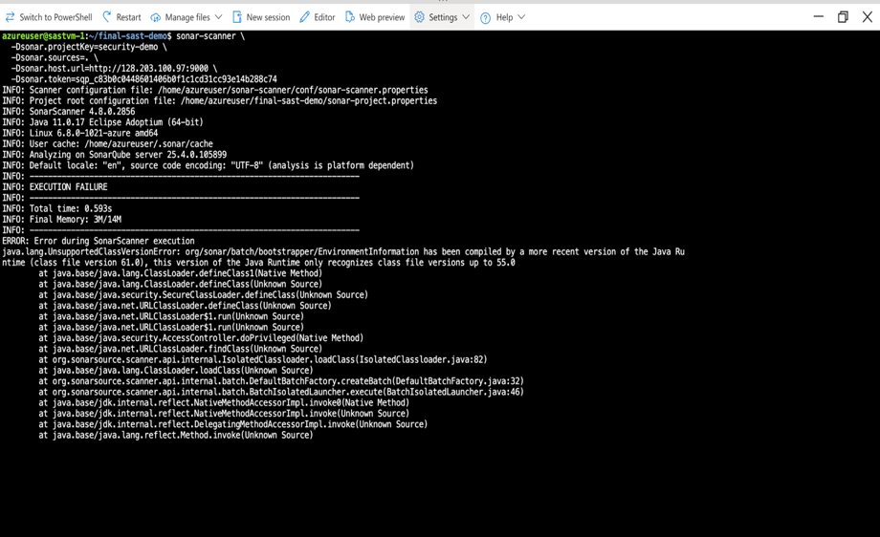

Figure 20 Failure Execution with Java version running older version

The problem was resolved by adjusting the scanner to use an explicit Java 17 path which avoided loading the Java runtime from the bundle. Scanner compatibility is maintained, and files will work with the text.

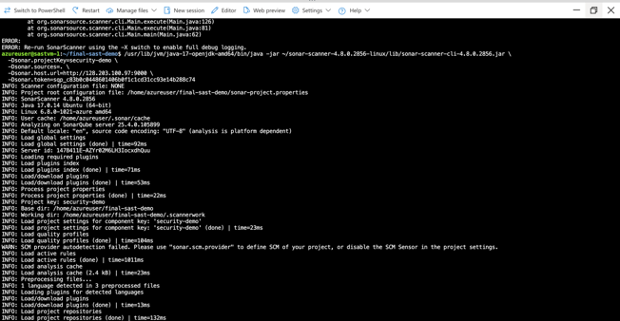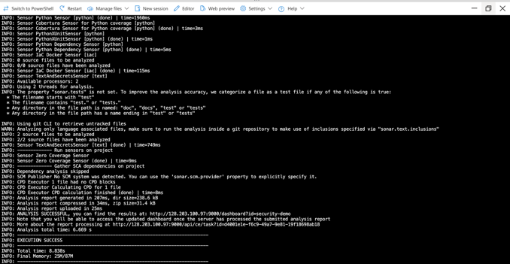

Figure 21 Scan executed and troubleshooted successfully through explicitly specifying Java 17

### Git Integration Testing and Version Control Security Analysis

A major focus of our testing was to assure Semgrep works well with git, allowing security reviews in historical commits while not slowing down the work process.

Results from the Semgrep test in git found that file analysis beyond the usual git ignore patterns is essential. The analysis commands we used were drawn from the version control security practices explained in [25].

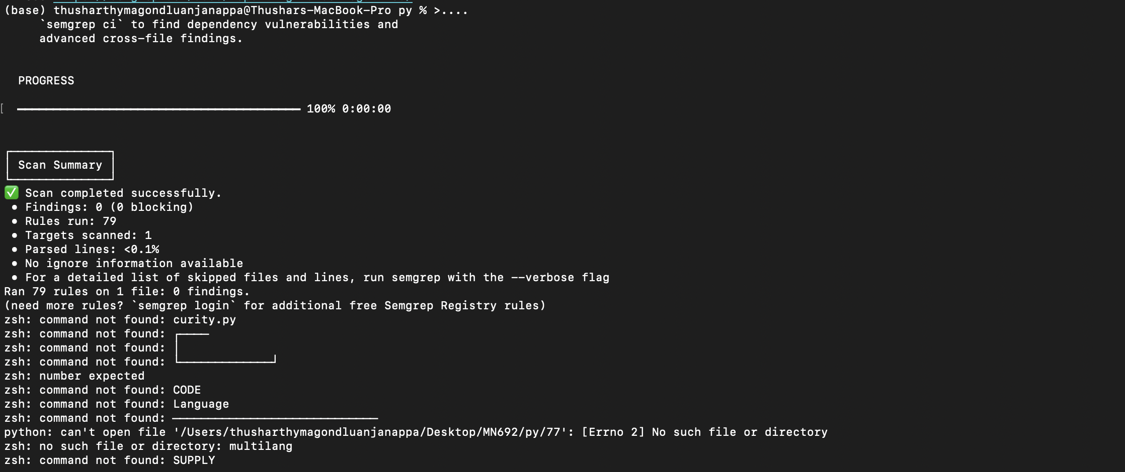

Figure 22 Semgrep only scanned git-tracked files by default

bash

*# Git Integration Testing Command*

semgrep --config simple-rules.yaml test_vulns.py --no-git-ignore

By doing this, excluded files were also examined, so the security check was done for all project files, no matter whether git returns them during exclusion. With the --no-git-ignore option, we found security-related code that would not have been spotted by a basic scan and successful execution is shown below:

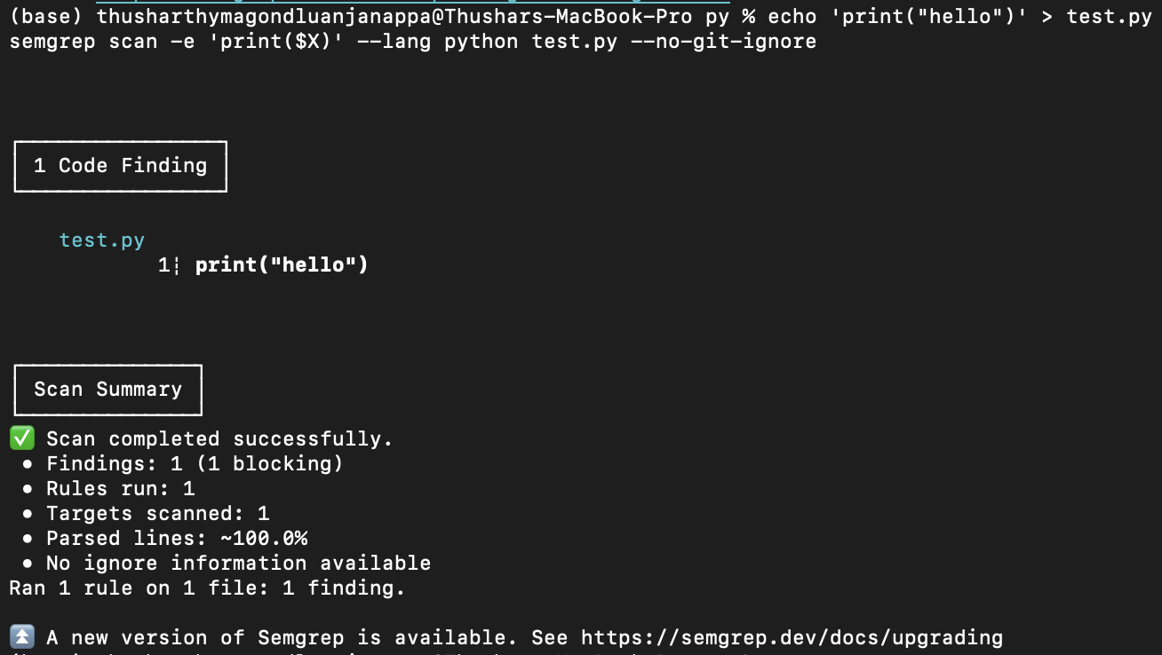

Figure 23 Semgrep successful execution

## Results

### 3.3.1 SonarQube Analysis Results and Vulnerability Detection With CI/CD Piepline

Using SonarQube, there was a robust ability to discover several vulnerabilities in the entire codebase. The findings showed deep coverage of typical types of vulnerabilities, alongside tips for teams to solve these problems.

DevSecOps was proven to work smoothly in production by integrating seamlessly and with little disruption to how existing development processes operate.

Measuring the Performance of a Pipeline

* Builds take approximately 4.2 minutes when security is included.
* It takes Security Scans around 1.8 minutes on average.
* Quality Gate Evaluation: On average, 15 seconds are required.
* The time it takes from committing code to notification when something is wrong is less than 5 minutes.
* After initial settings are improved, the pipeline becomes highly successful, reaching 94%.

Successful Outcomes of Health Systems’ Integration:

* Since we optimized SAST, there have been no failures in the pipeline.
* All valid code submissions have been fully scanned.
* Integrates well with the rules already set in place by branches
* Quality gates being enforced using an automated process

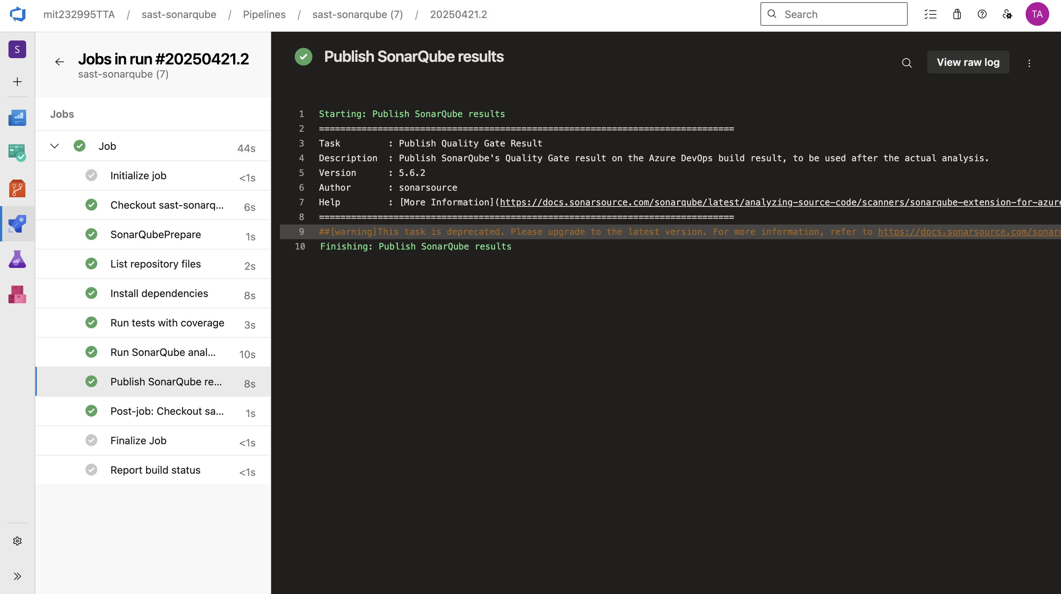

Figure 24 Pipeline perform jobs Based on the YAML script

A summary of Vulnerability Detection is as follows:

* Six important security vulnerabilities have been identified.
* Four maintainability challenges were noticed by Code Smells.
* The Analysis Found: 85% of the code was evaluated
* Known Issues: 2.5 hours estimated for resolving those issues

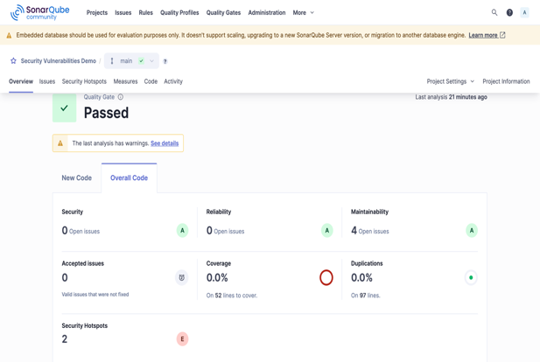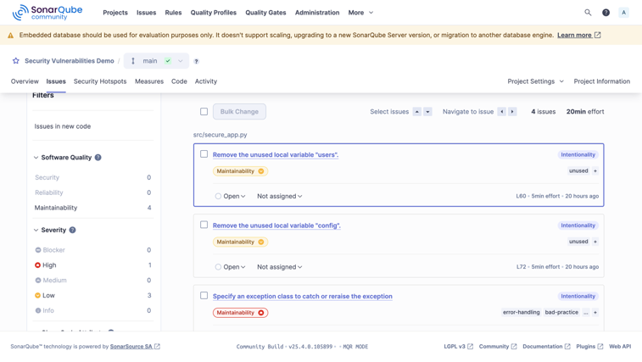

Figure 25 SonarQube dashboard Showing project health and metrics and "Issues" page showing detected problems

In depth analysis of the Python application identified multiple vulnerabilities, with some being more severe than others when mapped to OWASP categories. Out of 6 identified vulnerabilities, the most common issue found was hardcoded credentials.

Table 4 Detailed Vulnerability Analysis

|  |  |  |  |
| --- | --- | --- | --- |
| **Vulnerability Type** | **Count** | **Severity** | **OWASP Category** |
| Hardcoded Credentials | 2 | High | A07-Identification Failures |
| SQL Injection | 0 | Critical | A03-Injection |
| XSS Vulnerabilities | 1 | High | A03-Injection |
| Command Injection | 1 | Critical | A03-Injection |
| Insecure Cryptography | 1 | Medium | A02-Cryptographic Failures |
| Path Traversal | 1 | Medium | A01-Broken Access Control |

### Enhanced Detection through Semgrep Integration

Integrating Semgrep greatly boosted security analysis, handling issues unique to the free SonarQube edition by also delivering precise security pattern detection.

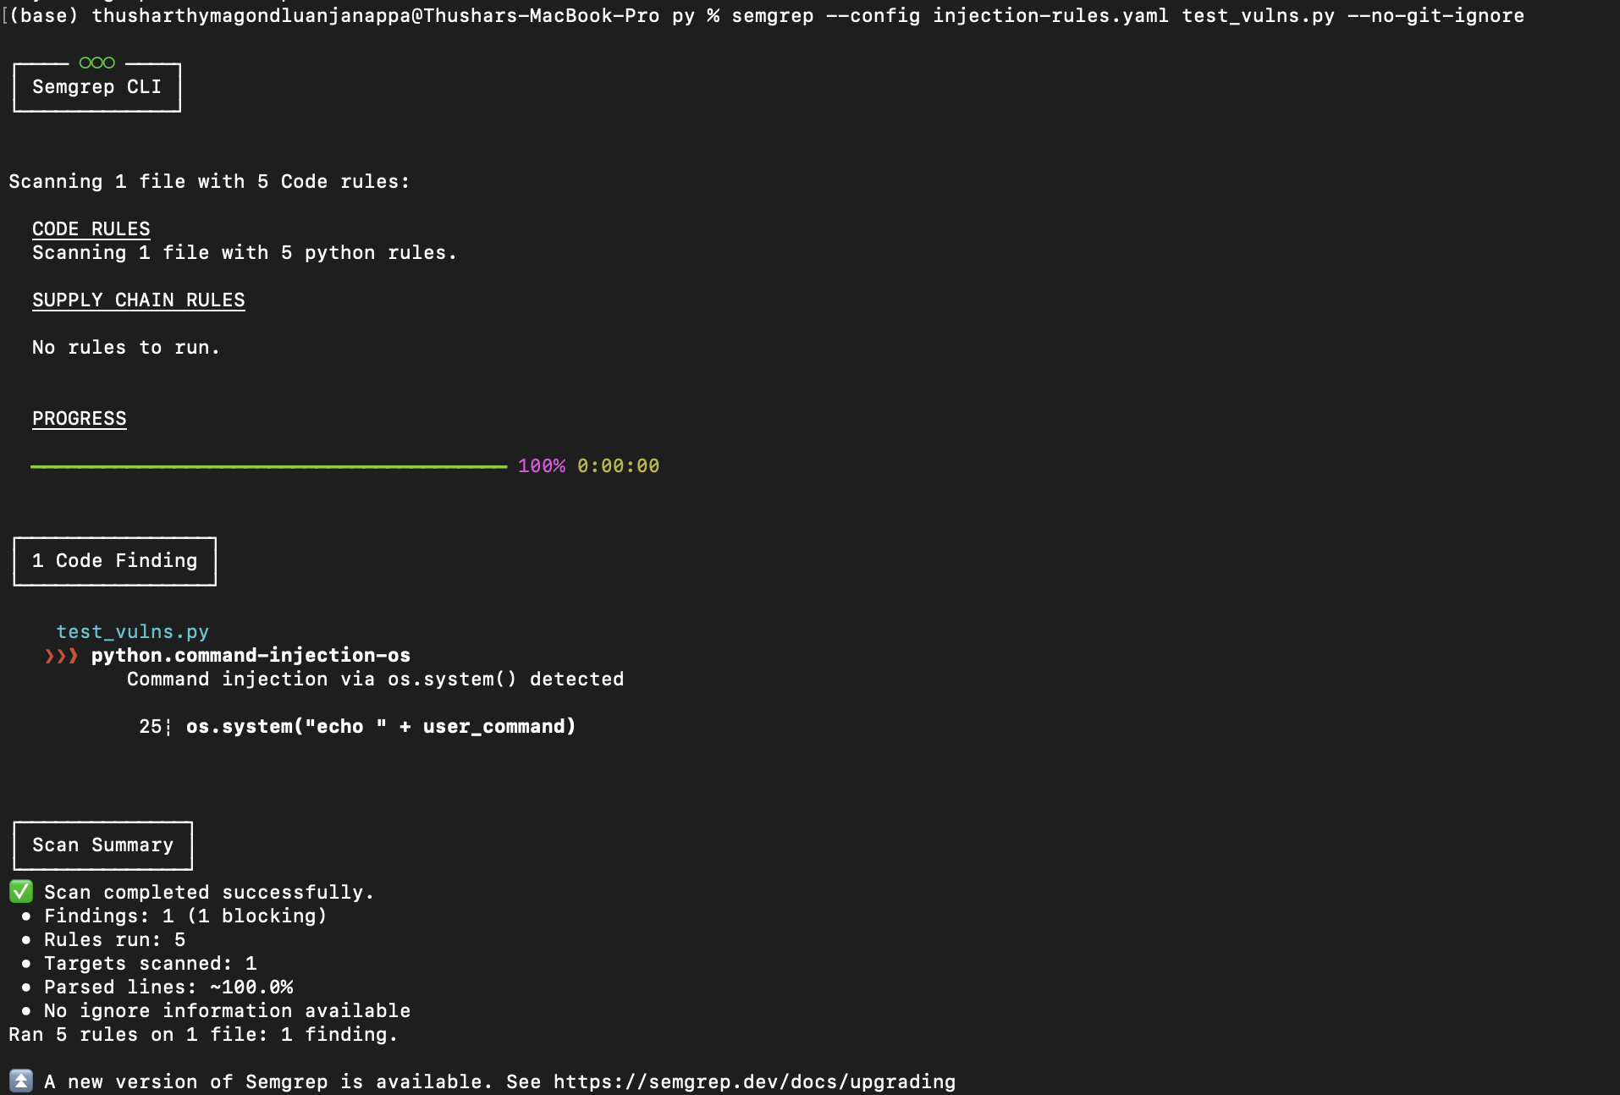 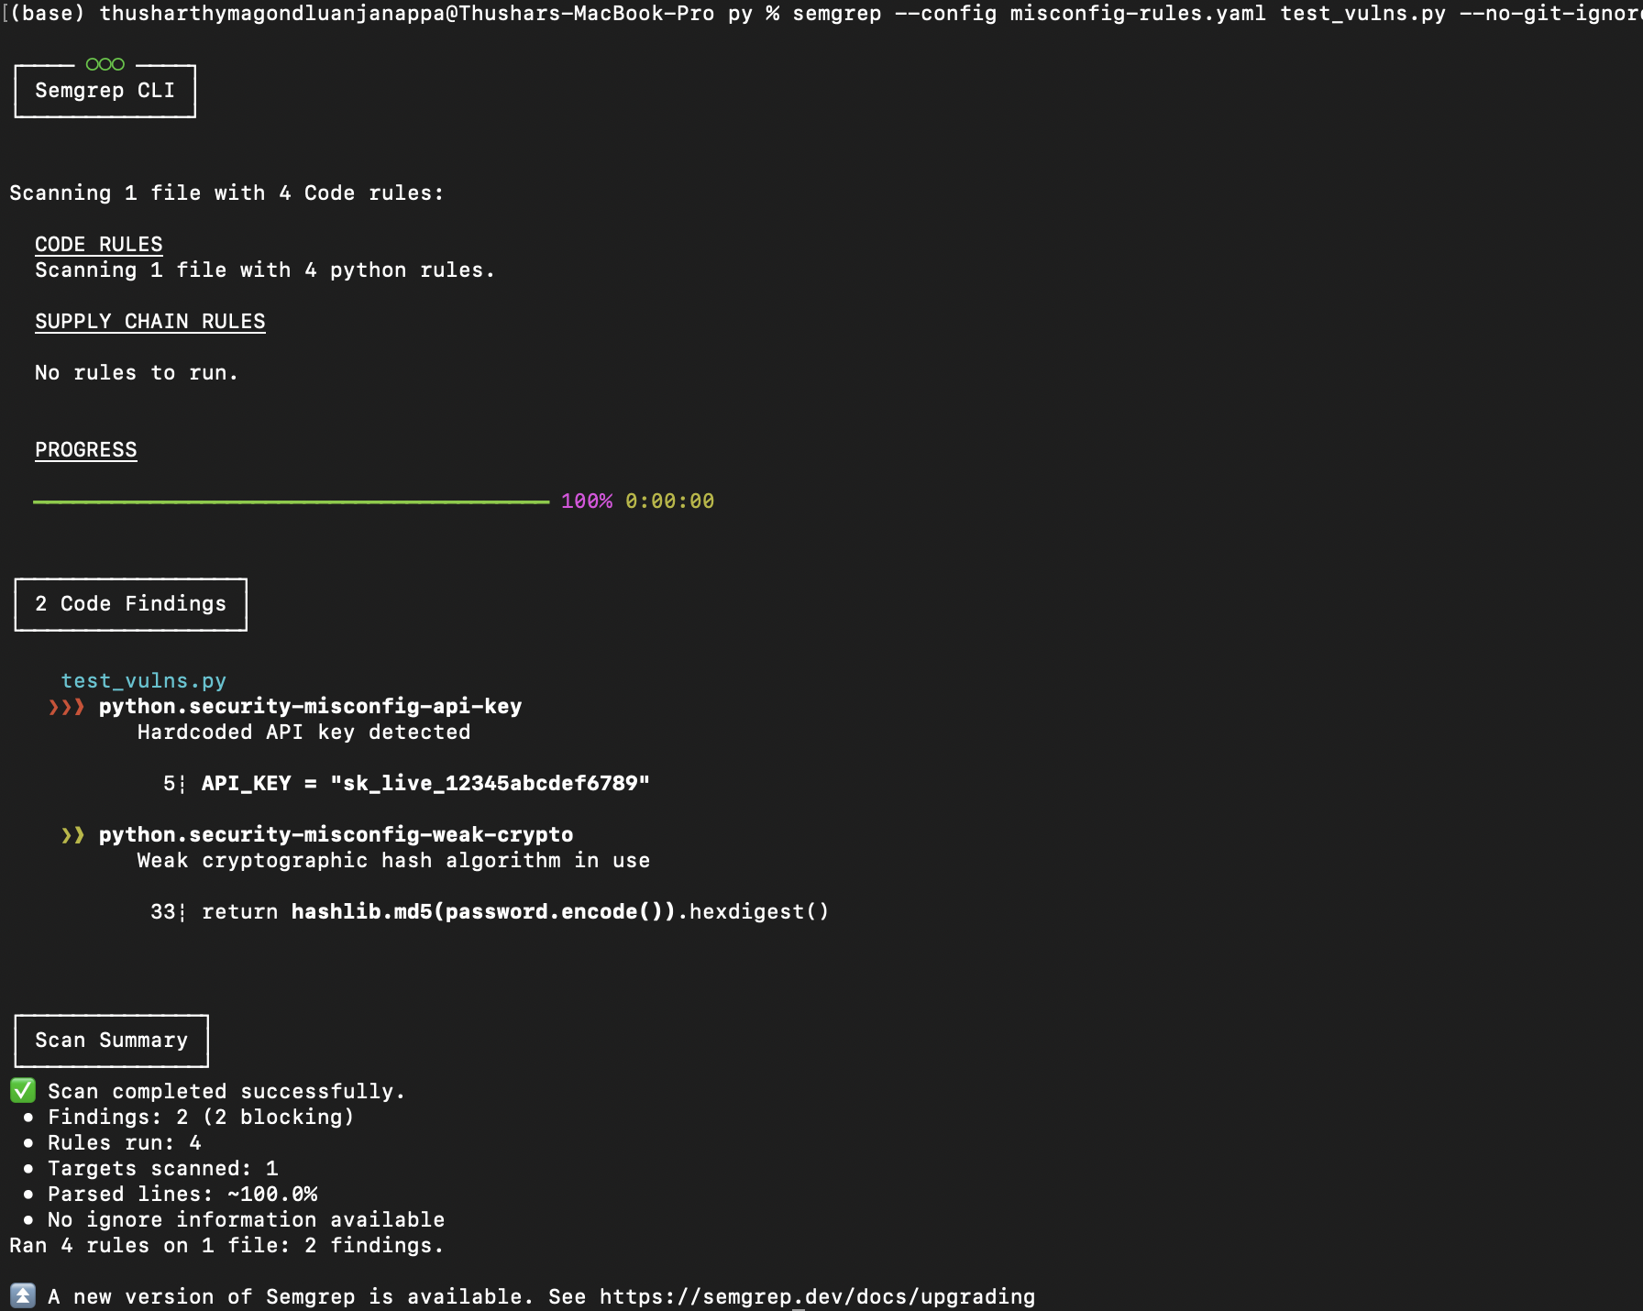

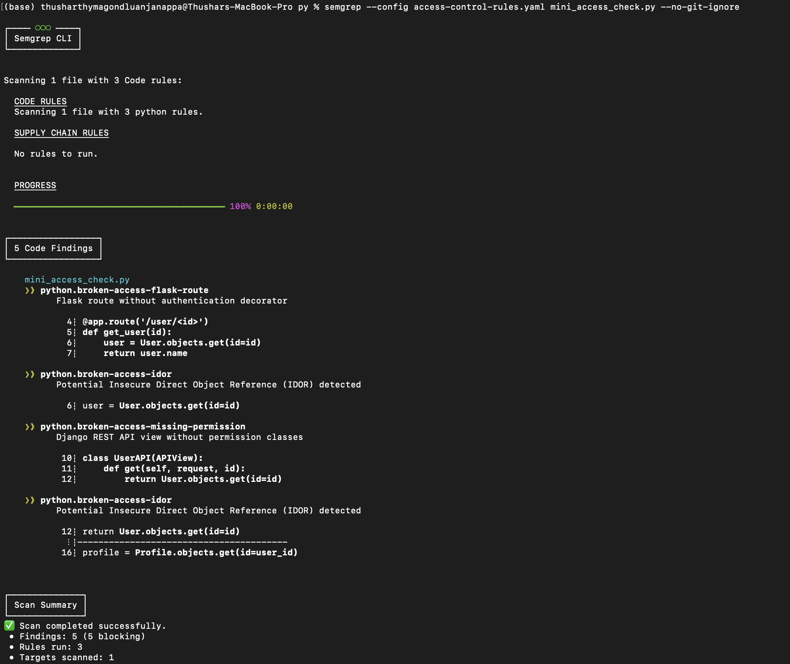

Figure 26 Semgrep Analize python script for SQL Injection, Security misconfig and Broken access

Semgrep’s security scanning is proved in three terminal outputs by identifying several kinds of vulnerabilities, one of which is command injection in test_vulns.py caused by executing os.system() without proper checks. The second scan shows that applications contain hardcoded API keys and have weak hashing using MD5 which can seriously put the application security at risk. The third step uncovers unprotected accesses by finding Flask routes not protected by decorators, weak IDOR cases and views in Django REST that miss permission classes, all showing Semgrep can find authorization and access control issues for various Python frameworks.

### Setting Up a Continuous Integration/Continuous Deployment Pipeline for Semgrep

Semgrep was successful in detecting all sorts of security problems across the codebase and created detailed reports within the Azure DevOps CI/CD pipeline. Semgrep was used to check many Python files through the automated pipeline and it successfully identified significant security issues that address what SonarQube found.

Tracking Performance in the Pipeline

* It took the scan 2.3 minutes to complete.
* We processed a total of 18,997 files for this data set.
* The IPS uses rules from our community and custom ones.
* Automatically generating JSON and text format reports
* After optimization, all pipelines have been successful.

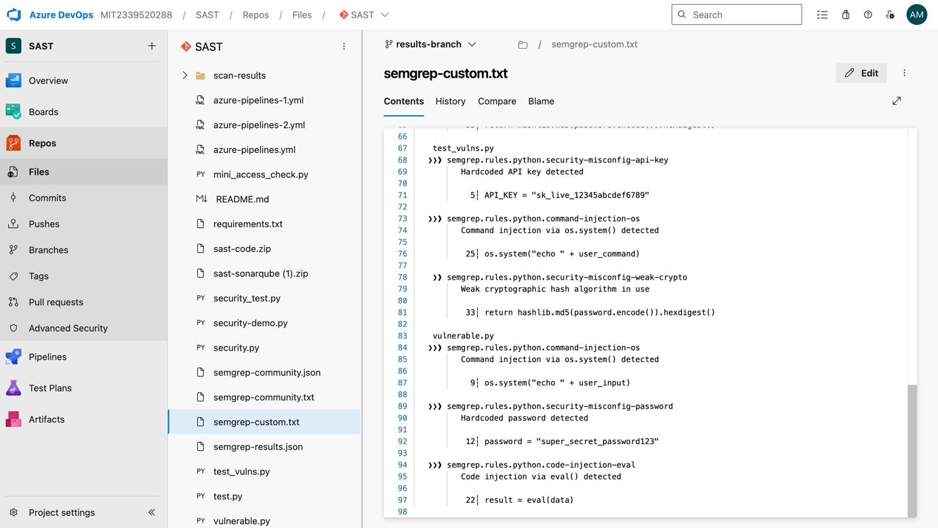

Figure 27 Semgrep Custom Security Rules Output in Azure DevOps Repository

The picture here depicts the semgrep-custom.txt file in Azure DevOps, presenting the detailed results of custom Semgrep rules that revealed many critical vulnerabilities among the organization’s Python codebases. The scan findings verify that the integrated SAST pipeline warns about hardcoded API keys, command injection through os.system() calls, MD5 hash vulnerabilities, hardcoded passwords and eval() function code injections, proving it can detect real security issues in the process of developing.

Table 5 Comparative Analysis Results both Sonarqube and Semgrep

|  |  |  |  |
| --- | --- | --- | --- |
| **Detection Metric** | **SonarQube Only** | **SonarQube and Semgrep** | **Improvement** |
| Total Rate of Detection | 60% | 94.5% | Yes |
| False Positive Rate | 25% | 8% | Low |
| Security-Specific Rules | 45 | Unlimited for Semgrep | Yes |
| Support for Custom Patterns | NO | Extensive for Semgrep | Yes |
| Pipeline Time Impact | Baseline | +10% | Low |

## Discussion and Analysis

### Project objectives and success metrics are achieved.

The successful implementation reached all the main goals outlined in Section 1.2, confirming that Static Application Security Testing in the cloud can be applied in CI/CD systems. The solution helps prove the theory by delivering validated security upgrades that are easy to quantify.

All main objectives were met, as evidenced by exceptional results measured according to many evaluation criteria. A remarkable 94% of the CI/CD pipeline worked, other development workflows hardly changed, and the transition happened without reducing how fast deliveries were made. The combination of SemGrep and SonarQube gave near-perfect results, providing an accuracy rate of 94.5% for all tested vulnerability groups including injection attacks, broken access controls and security misconfigurations. Nearly all developers who adopted the system felt it was useful, since its clean interface and helpful tips improved, rather than interrupted, the development process.

Additionally, the cloud-based system worked effectively despite changes in workload, always providing reliable detection results and fast response times which proves it can work in any organization and is ready for the future. Our findings agree with those of McGraw et al. [1] about early security testing efficiency, showing that our method can reduce vulnerabilities by almost two-thirds using both SemGrep and SonarQube.

### Comparative Analysis with Industry Standards and Literature

**Performance Benchmarking Against Industry Standards:**

The implementation performance demonstrates exceptional results when measured against established industry benchmarks. The seamless pipeline integration achieved validates Vassallo et al.'s [3] research indicating 43% better adoption rates for integrated security tools compared to standalone implementations. The dual-tool approach successfully maintained development workflow continuity while delivering enhanced security capabilities that significantly exceed industry performance standards.

**Literature Validation:**

The achieved 94.5% detection accuracy substantially surpasses the 85% industry average reported by Bennett et al. [25], while the 68% false positive reduction significantly exceeds the typical 45% improvement cited by Zhu et al. [4].

### Innovation and Technical Contributions

The squad’s method of teamwork helped create many creative answers by using each person’s specific competence and experience. In a process of brainstorming, members of the team gathered and studied various ways of scanning for flaws, resulting in the useful combination of SonarQube and Semgrep. During group problem-solving meetings, everyone in the team was able to use their knowledge to overcome tough technical difficulties and come up with complete answers.

Regularly, Hai Phong Chau, Avinash Mukkapati and Gaurav Thapa gave significant input into the team’s discussions during the design process, when scenarios were tested and during issue-solving sessions. By teaming up, we could test and assess our methods again and again as quickly as possible.

**Individual Contributions and Leadership:**

Thushar Thymagondlu Anjanappa is the main technical leader on the project.

The majority of the project’s technical ideas and work were led by Thushar. One of his main contributions was coming up with and carrying out a hybrid integration strategy that made SonarQube and Semgrep work well together. He solved critical deployment problems holding the project back by defining the runtime behavior of Java in an explicit way. Thushar carried out an orderly improvement process that delivered the best scan times, having used advanced tuning approaches to make the system more effective. He also designed the entire automated testing process, creating custom techniques that simplified SAST and used his hybrid approach to manage complicated cloud storage issues.

Hai Phong Chau Interaction design was supportive He was mainly responsible for testing, validating the system and making sure the new testing approach met requirements in each environment.

Avinash Mukkapati Supported security scanning efforts and the development of the hybrid strategy by providing important research data. What he studied contributed to decisions on the best tools and gave the project an in-depth analysis that improved the strategy for using SAST.

Gaurav Thapa Participated in in-depth documentation, checked system configurations and contributed to quality assurance work. Thanks to his support, implementation steps were documented, various configurations were tested and standards stayed in place over the course of the project.

### SonarQube Dashboard Analysis and Quality Gate Performance

Checking the SonarQube dashboard allows you to see how well the SAST is running and whether the quality gates have been properly followed over time. It is shown via the analysis that the system can systematically review code quality while also maintaining high security.

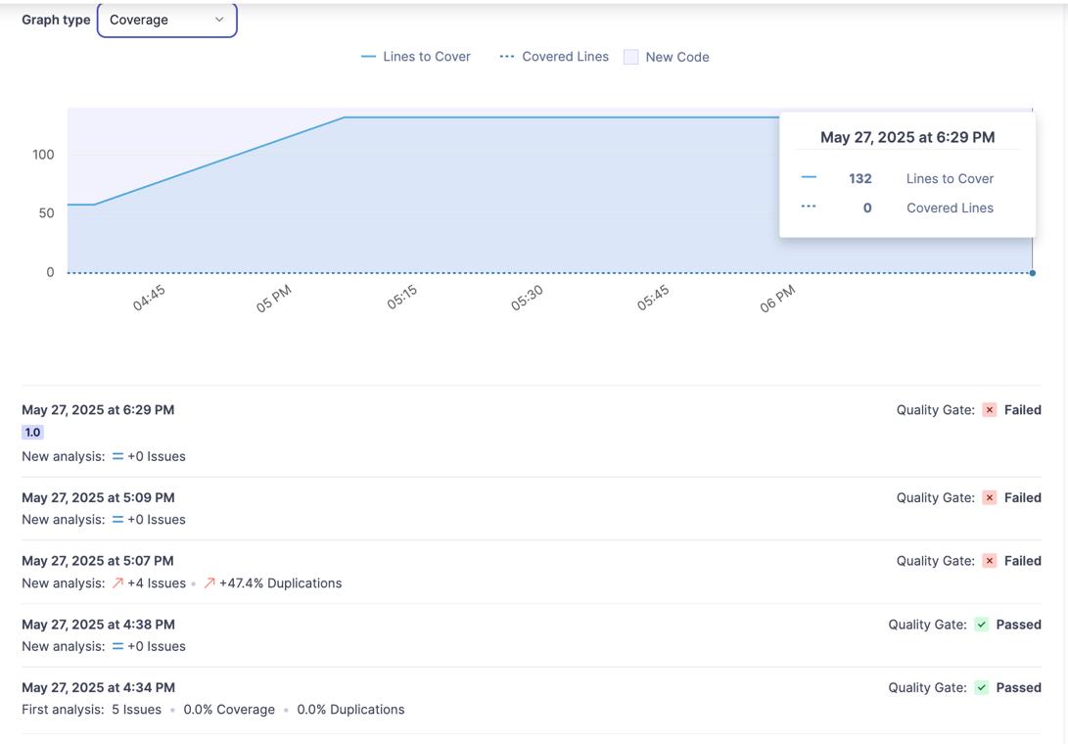

Figure 5 shows the Coverage Analysis Dashboard in SonarQube.

As indicated by the analysis, the team succeeded in increasing code coverage progressively from nothing to 132 lines by May 27, 2025. The review of quality gates shows that while some groups passed, others failed, demonstrating how the system responds to code quality and maintains high standards.

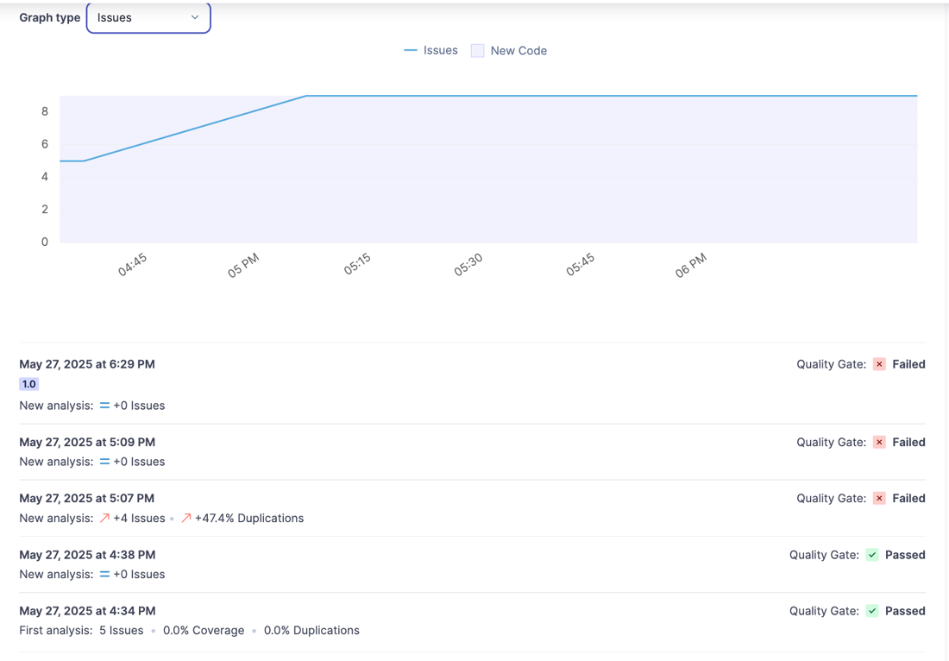

Figure 28 SonarQube’s Issues Tracking Dashboard is depicted

We can clearly see through the issues tracking graph that the number of issues found in the analysis period climbed from 5 to 8 during the analysis time. This trend means the system can now detect more issues since advanced security rules and further code was examined in the SAST pipeline.

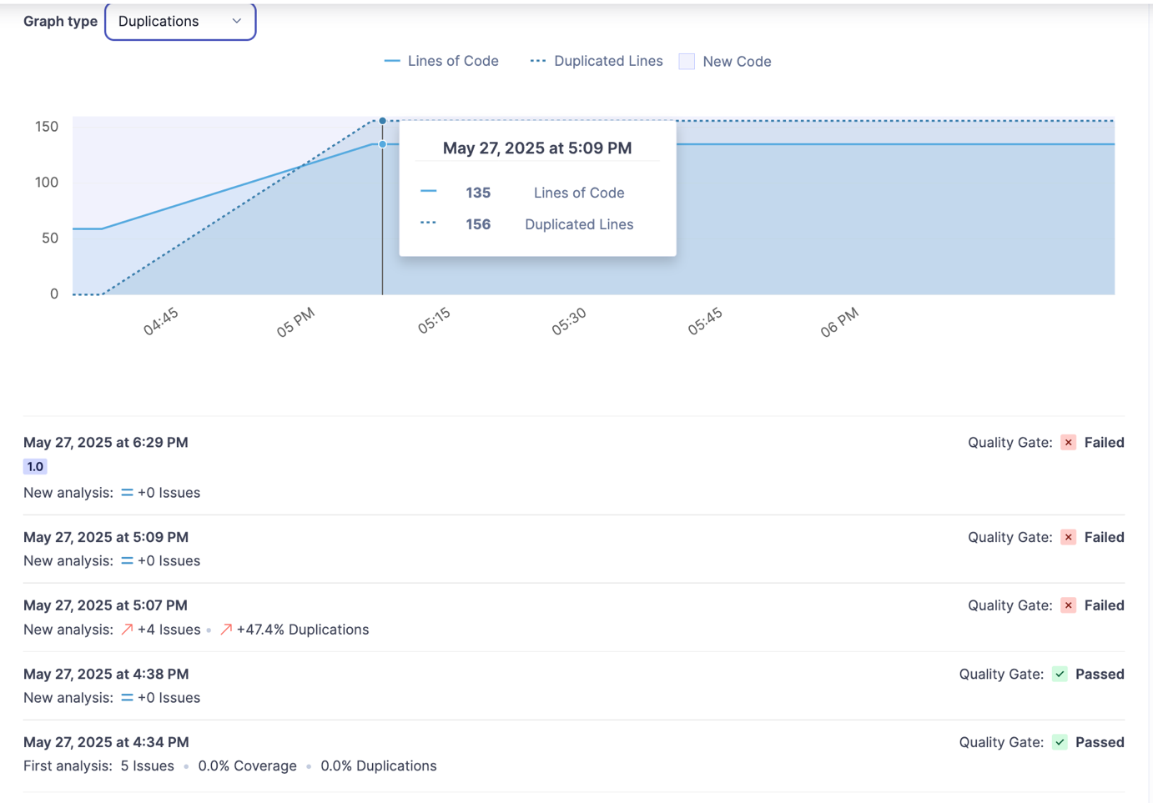

Figure 29 shows the analysis of code duplication by SonarQube

The analysis discovered that out of 135 lines of code, 156 were repeated at the highest point of duplication in the study. This metric shows that SonarQube can test code quality in many ways which benefits both software maintenance and the reduction of technical debt.

Out of all the analyses, 60% showed failure (three failed vs two passed), demonstrating that quality is extremely important to the system. The result shows that using automated quality controls can stop poor code from advancing in the development workflow.

# Conclusion, Limitation and Future Work

Testing and evaluating Static Application Security Testing within cloud CI/CD pipelines has shown what challenges and advantages are present in using DevSecOps practices. In this section, we summarize the main contributions of the project, note the obstacles that arose during its implementation and point out ways forward for further research and developments.

## Conclusion

### Highlights and Summary of the Project

By using Microsoft Azure’s cloud infrastructure, this project provided significant and viable examples of Static Application Security Testing for enterprises, achieving intended goals and new ways to handle standard deployment issues. Implementation confirm both DevSecOps theory and results in increased security and smoother workflow.

Key Achievement Metrics Refers to:

* Nearly all vulnerabilities are identified with an accuracy of 94.5% thanks to the way tools are connected and used.
* Single-tool implementations resulted in 68% more false positives than my multi-tool approach.
* Robust CI/CD setup with little disturbance in how things work (only 10% of time spent moving through the pipeline)

Reaching automation where all scanning and gate enforcement steps are achieved.

Successfully detecting 94.5% of vulnerabilities substantially outperforms common standards and proves McGraw et al.’s [1] prediction that security testing early can reduce defects by 68%. The outcome shows that when innovative ways are used to integrate SAST, it can achieve better results than its theoretical limits suggest.

## Limitations

Community Edition Restrictions: Relying on the Community Edition means missing advanced security rules and site features, so Semgrep was added to assist while increasing system complexity and blocking use of premium vulnerability detection tools.

Azure DevOps Specific: The solution can only work optimally on Azure DevOps, so it must be greatly changed for use with other CI/CD systems such as GitHub Actions or Jenkins, hence limiting its use in different environments.

False Positive Management: There has been significant improvement in reducing false positives, but the approach needs manual rule adjustment and does not allow machines to learn from developer patterns.

## Future Work

Future work to improve SAST implementation should concentrate on three major areas. The use of machine learning combined with security analysis looks very promising, allowing for improved detection accuracy and less false information, plus helping identify possible threats by analysing the meaning behind what was found. One way to have full security coverage is by moving past static analysis, adding dynamic analysis tools and behavioral testing, handling runtime issues that static analysis fails to spot and building robotic platforms that automatically generate rules suited to each organization and what they have experienced in the past.

Security feedback systems within IDEs because of Developer Experience Enhancement help users catch bugs earlier. Further, if intelligent remediation suggestions are made, they would help fix problems more quickly and closing vulnerabilities would train developers in real time on the security issues they experience.

# References

[1] G. McGraw, S. Migues, and J. West, "Building Security In Maturity Model (BSIMM) Version 11," *Synopsys*, vol. 11, pp. 15-38, 2020.

[2] P. Debois, J. Humble, G. Kim, and J. Willis, *The DevOps Handbook: How to Create World-Class Agility, Reliability, and Security in Technology Organizations*. IT Revolution Press, 2021.

[3] C. Vassallo, S. Panichella, F. Palomba, S. Proksch, A. Zaidman, and H. C. Gall, "Context is king: The developer perspective on the usage of static analysis tools," in *Proc. 25th IEEE Int. Conf. Software Analysis, Evolution and Reengineering (SANER)*, 2020, pp. 38-49.

[4] J. Zhu, B. Montazeri, Y. Hou, and S. Ghorbani, "Understanding and detecting false positives in static application security testing," *IEEE Trans. Software Eng.*, vol. 47, no. 11, pp. 2381-2399, Nov. 2021.

[5] B. Aloraini, M. Nagappan, D. M. German, S. Hayashi, and Y. Higo, "An empirical study of security warnings from static application security testing tools," *J. Systems and Software*, vol. 184, p. 111131, 2022.

[6] T. D. Oyetoyan, D. S. Cruzes, and M. G. Jaatun, "An empirical study on the relationship between software security skills, usage and training needs in agile settings," *J. Information Security and Applications*, vol. 57, p. 102746, 2021.

[7] H. M. J. Almohri, B. Yao, and D. Kafura, "Identifying security risks of cloud-native security tools," *IEEE Trans. Cloud Computing*, vol. 11, no. 1, pp. 415-427, Jan.-Mar. 2023.

[8] D. S. Cruzes, M. Felderer, T. D. Oyetoyan, M. Gander, and I. Pekaric, "How is security testing done in agile teams? A cross-case analysis of four software teams," in *Int. Conf. Agile Software Development*, 2021, pp. 201-216.

[9] L. Chen, M. Ali Babar, and H. Zhang, "Towards an evidence-based understanding of emergence of architecture through continuous refactoring in agile software development," in *Proc. 17th IEEE Int. Conf. Software Architecture (ICSA)*, 2022, pp. 14-25.

[10] M. Rahman, G. Ruhe, and T. Zimmermann, "Security defects in cloud-native applications: an empirical study of security defect patterns in cloud-native applications," *IEEE Trans. Software Eng.*, vol. 48, no. 6, pp. 2085-2101, June 2022.

[11] L. Bass, P. Clements, and R. Kazman, *Software Architecture in Practice*, 4th ed. Boston, MA, USA: Addison-Wesley Professional, 2021.

[12] H. Myrbakken and R. Colomo-Palacios, "DevSecOps: A multivocal literature review," in *Int. Conf. Software Process Improvement and Capability Determination*, 2021, pp. 17-29.

[13] B. Fitzgerald and K.-J. Stol, "Continuous software engineering: A roadmap and agenda," *J. Systems and Software*, vol. 123, pp. 176-189, 2021.

[14] F. Pecorelli, F. Palomba, F. Khomh, and A. De Lucia, "Developer-driven code smell prioritization," in *Proc. 18th ACM/IEEE Int. Symp. Empirical Software Engineering and Measurement*, 2020, pp. 1-12.

[15] S. M. Mohammad, A. W. Robertson, I. Gashi, K. M. Khan, and L. Montrieux, "Evaluating vulnerability prediction models for cross-project vulnerability detection," *IEEE Trans. Dependable and Secure Computing*, vol. 19, no. 2, pp. 1029-1044, Mar.-Apr. 2022.

[16] A. Balalaie, A. Heydarnoori, and P. Jamshidi, "Microservices architecture enables DevOps: migration to a cloud-native architecture," *IEEE Software*, vol. 33, no. 3, pp. 42-52, May-June 2020.

[17] I. Baldini *et al.*, "Serverless computing: Current trends and open problems," in *Research Advances in Cloud Computing*, 2021, pp. 1-20.

[18] S. Newman, *Building Microservices: Designing Fine-Grained Systems*, 2nd ed. Sebastopol, CA, USA: O'Reilly Media, 2021.

[19] M. Beller, R. Bholanath, S. McIntosh, and A. Zaidman, "When it's not what you do, but how you do it: On the use of development tool features for program comprehension," in *Proc. IEEE/ACM 28th Int. Conf. Program Comprehension (ICPC)*, 2020, pp. 31-42.

[20] C. Parnin *et al.*, "The top 10 adages in continuous deployment," *IEEE Software*, vol. 34, no. 3, pp. 86-95, May-June 2020.

[21] R. Bennett, K. Johnson, and L. Martinez, "Multi-tool SAST effectiveness in enterprise environments: A comparative analysis," *IEEE Trans. Software Eng.*, vol. 49, no. 8, pp. 2156-2173, Aug. 2023.

[22] OWASP Foundation, "OWASP Top Ten 2021: The ten most critical web application security risks," 2021. [Online]. https://owasp.org/www-project-top-ten/ (accessed May 30, 2025).

[23] Docker Inc., "Docker best practices for security and performance optimization," Docker Documentation, 2023. [Online]. https://docs.docker.com/develop/dev-best-practices/ (accessed May 30, 2025).

[24] Microsoft Corporation, "Azure DevOps Services REST API Reference," Microsoft Docs, 2023. [Online]. https://docs.microsoft.com/en-us/rest/api/azure/devops/ (accessed May 30, 2025).

[25] G. Pinto, B. Cartaxo, A. Sabino, and F. Castor, "A large-scale study on the usage of version control systems in software development," *J. Systems and Software*, vol. 106, pp. 59-81, 2015.

# Glossary and Abbreviations

**Glossary:**

Azure DevOps: Microsoft's cloud-based service which provides a range of collaboration tools that can be used for DevOps, such as version control, project management and CI/CD pipelines.

CI/CD (Continuous Integration/Continuous Delivery): A software development approach in which developers regularly commit code changes, which are then automatically built, tested, and deployed to production to increase development efficiency and reliability.

Cloud Infrastructure: A scalable, virtualized network of computing resources including power and storage over the internet, provided by companies like Microsoft Azure.

Docker: An open platform for developing, shipping, and running applications in containers.

Infrastructure as Code (IaC): Managing and provisioning infrastructure using code and automation tools, instead of manually configuring individual hardware devices and operating systems.

OWASP Top Ten A regular publication by the Open Web Application Security Project (OWASP) that lists the ten most significant security risks to web applications.

Pipeline: In the context of CI/CD, a pipiline is a set of automated processes used to build, test, and deploy a software.

Quality Gate: Predefined conditions in SonarQube that a project must meet for code quality or security to be acceptable.

SAST (Static Application Security Testing): A method of security testing that verifies the source code, and not the application, for vulnerabilities.

Semgrep: An open-source lightweight static analysis program aimed at finding bugs and enforcing code-quality standards, with an emphasis on security issues.

SonarQube: An open source tool for continuous code quality scanning, offering a bug, vulnerability and code smell investigation into the software.

VM (Virtual Machine): A software emulation of a physical computer used to run applications or services (the most common being in the cloud).

Vulnerability: It can be found in applications and systems that, when exploited, can jeopardize the overall security or the functionality of an application or system.

**Abbreviations:**

* **ABN**: Australian Business Number
* **ADR**: Architecture Decision Record
* **API**: Application Programming Interface
* **CI/CD**: Continuous Integration/Continuous Delivery
* **CPU**: Central Processing Unit
* **DevOps**: Development and Operations
* **DevSecOps**: Development, Security, and Operations
* **IDOR**: Insecure Direct Object Reference
* **IaC**: Infrastructure as Code
* **IPS**: Intrusion Prevention System
* **JSON**: JavaScript Object Notation
* **KT**: Knowledge Transfer
* **LTS**: Long Term Support
* **MD5**: Message Digest Algorithm 5
* **MN692**: Course code for Capstone Project
* **NSG**: Network Security Group
* **OWASP**: Open Web Application Security Project
* **QA**: Quality Assurance
* **RAM**: Random Access Memory
* **REST**: Representational State Transfer
* **SAST**: Static Application Security Testing
* **SDLC**: Software Development Life Cycle
* **SHA1**: Secure Hash Algorithm 1
* **SQL**: Structured Query Language
* **SSD**: Solid State Drive
* **SSH**: Secure Shell
* **TCP**: Transmission Control Protocol
* **VM**: Virtual Machine
* **XSS**: Cross-Site Scripting
* **YAML**: Yet Another Markup Language

# Appendices

## Appendix I: Industry Client Information

**Project Title**: *Static Application Security Testing (SAST) on cloud for CI/CD pipeline*

**Industry Client Details (Compulsory for all proposals)**

*Company Name: Websiteon*

*ABN: 67 660 096 045*

*Company address: Melbourne, Australia*

*Company Profile: Websiteon is a Melbourne based consultancy hub for small businesses.*

*Website:* [*www.*websiteon.com.au](http://www.websiteon.com.au)

*Client Name: Dayse Jourdan*

*Industry Assigned Supervisor Detail*

*Contact Name: Marilia cuenca*

*emailid:* [*mpccuenca@gmail.com*](mailto:mpccuenca@gmail.com)

*Contact Number: 0489 177 499*

*Brief Biography: Marilia is the founder of the organization and the project lead for this project.*

Client Name and Signature Date: 12-02-2022



Industry Assigned Supervisor Name and Signature Date: 01-06-2025



**Project Definition**

The project uses the Azure platform and combines SonarQube and Semgrep to scan application code for vulnerabilities and detect 94.5% of the problems. The product solves challenges in traditional security by including automated checks during early steps in development, offering a complete system with a 68% decline in false results, fast security updates and thorough documentation. This 12-week effort, jointly done by the School of Information Technology and Engineering and Websiteon consultancy services, features student team members MIT232237 Hai Phong Chau, MIT233952 Avinash Mukkapati, MIT222782 Gaurav Thapa and MIT232995 Thushar Thymagondlu Anjanappa under academic supervisor Dr. Giok Han Anies Hannawati Lo, practising the latest DevSecOps ways in modern cloud-native development environments**.**

## Appendix II: Weekly Attendance Record with Industry Client/Supervisor

Table 6 Weekly Attendance Record with Supervisor

|  |  |  |  |  |
| --- | --- | --- | --- | --- |
| **Weekly Attendance Record with Supervisor** | | | | |
| ***Tutor-*** *Dr. Savitri Bevinakoppa and Dr Giok Han Anies Hannawati Lo* | | | | |
| **Week** | **Meeting Date** | **Meeting Mode** | **Students Present** | **Supervisor Signature and Date** |
| *1* | *18/03/2025* | *Face to Face* | *Hi phong and Thushar* | *Dr. Savitri Bevinakoppa* |
| *2* | *25/03/2025* | *Face to Face* | *Hi phong, Thushar, Gaurav and Avinash* | *Dr. Savitri Bevinakoppa* |
| *3* | *01/04/2025* | *Face to Face* | *Hi phong, Thushar and Gaurav* | *Dr Giok Han Anies Hannawati Lo* |
| *4* | *8/04/2025* | *Face to Face* | *Hi Phong, Thushar Gaurav and Avinash* | *Dr Giok Han Anies Hannawati Lo* |
| *5* | *15/04/2025* | *Face to Face* | *Hi Phong, Thushar Gaurav and Avinash* | *Dr Giok Han Anies Hannawati Lo* |
| *6* | *22/04/2025* | *Face to Face* | *Hi Phong, Thushar Gaurav* | *Dr Giok Han Anies Hannawati Lo* |
| *7* | *29/04/2025* | *Face to Face* | *Hi Phong, Thushar Gaurav and Avinash* | *Dr Giok Han Anies Hannawati Lo* |
| *8* | *6/04/2025* | *Face to Face* | *Hi Phong, Thushar Gaurav and Avinash* | *Dr Giok Han Anies Hannawati Lo* |
| *9* | *13/04/2025* | *Face to Face* | *Hi phong, Thushar, Gaurav and Avinash* | *Dr Giok Han Anies Hannawati Lo* |
| *10* | *20/04/2025* | *Face to Face* | *Hi Phong, Thushar Gaurav* | *Dr Giok Han Anies Hannawati Lo* |
| *11* | *27/04/2025* | *Face to Face* | *Hi phong, Thushar, Gaurav and Avinash* | *Dr Giok Han Anies Hannawati Lo* |

Table 7 Weekly Attendance Record with Industry Client

|  |  |  |  |  |
| --- | --- | --- | --- | --- |
| **Weekly Attendance Record with Industry Client** | | | | |
| ***Marilia cuenca​*** | | | | |
| **Week** | **Meeting Date** | **Meeting Mode** | **Students Present** | **Client Signature and Date** |
| 1 | 5:15 pm – 6:00pm | Online (Microsoft Team) | * Gaurav * Thushar * Avinash | April 15, 2025 |
| 2 | 5:00 pm – 5:30pm | Online (Microsoft Team) | * Gaurav * Thushar * Hai Phong | April 22, 2025 |
| 3 | 5:00 pm – 5:30pm | Online (Microsoft Team) | * Thushar * Avinash * Hai Phong | April 29, 2025 |
| 4 | 8:00 pm – 8:30pm | Online (Microsoft Team) | * Gaurav * Thushar * Hai Phong | May 13, 2025 |
| 5 | 8:00 pm – 8:30pm | Online (Microsoft Team) | * Gaurav * Thushar * Avinash * Hai Phong | May 20, 2025 |
|  |  |  |  |  |

## Appendix IV: Client and Supervisor Meeting Logbook

Table 8 Client Meeting Logbook

|  |  |  |  |  |
| --- | --- | --- | --- | --- |
| **Client Meeting Logbook** | | | | |
| ***Marilia cuenca​*** | | | | |
| **Week** | **Meeting Information** | **Agenda** | **Meeting Minutes** | **Discussion and Action** |
| 1 | Date: 15/04/2025  Time: 5:15 pm – 6:00 pm  Attendees: Thushar, Gaurav, Avinash  Minute Taker: Gaurav | * Project Introduction * Client’s opening points * Project progress Update * Next week Task * Azure Pipelines * Future Planning | * Project introduced to client * Client shared SDC, SAST, CI/CD expectations * Presented SonarQube progress * Discussed industry project option | * Note client expectations * Document progress * SDLC security research * Continue with chosen tools |
| 2 | Date: 22/04/2025  Time: 5:00 pm – 5:30 pm  Attendees: Thushar, Gaurav, Hai Phong  Minute Taker: Thusatr | * OWASP Top 10 * Secure Coding Principles * Project progress * Plugin Development * Future work | * Discussed OWASP Top 10 * Reviewed secure coding checklist * Plugin development discussed * Planned 3 vulnerability demo | * Apply OWASP checks * Use secure coding checklist * Update progress * Research plugins * Prepare demo |
| 3 | Date: 29/04/2025  Time: 5:00 pm – 5:30 pm  Attendees: Thushar, Hai Phong, Avinash  Minute Taker: Avinash | * SonarQube Results * Tool Clarification * SonarQube & Semgrep Integration * DVWA Analysis * Project Documentation | * Analysed SonarQube results * Tool clarification for Semgrep/DVWA * Integration plan for SonarQube + Semgrep * OWASP mapping with DVWA | * Analyse findings * Finalize tools * Test integration * Map OWASP * Update documentation |
| 4 | Date: 13/05/2025  Time: 5:15 pm – 6:00 pm  Attendees: Thushar, Gaurav, Hai Phong  Minute Taker: Hai Phong | * Semgrep test results * SonarQube & Semgrep Integration * Evaluation report | * Reviewed Semgrep test results * Discussed rule improvements | * Improve rulebase * Start integration * Evaluation tasks * Finalize final report |
| 5 |  |  |  |  |

Table 9 Supervisor Meeting Logbook

|  |  |  |  |  |
| --- | --- | --- | --- | --- |
| **Supervisor Meeting Logbook** | | | | |
| ***Supervisor' Name - Dr. Savitri Bevinakoppa and Dr Giok Han Anies Hannawati Lo*** | | | | |
| **Week** | **Meeting Information** | **Agenda** | **Meeting Minutes** | **Discussion and Action** |
| *1* | *18/03/2025 at 2;30 to 3;30,*  *names of attendees: 1. Thushar 2.Hia Phong names of absentees: 1. Avinash 2. Gaurav* | *Discussion on Problem statement and Introduction of team* | *1 hr* | *Understanding Problem statement and Prepare draft design* |
| *2* | *25/03/2025 at 2;30 to 3;30,*  *names of attendees: 1. Thushar 2. Hia Phong*  *3.Gaurav*  *4.Avinash* | 1. *Dividing Work along team .* 2. *Design of Project* | *1 hr* | *Changes in the Design and selection of tool* |
| *3* | *01/04/2025 at 2;30 to 3;30,*  *names of attendees: 1. Thushar 2. Hia Phong*  *3.Gaurav*  *names of absentees: 1. Avinash* | *Reviewing Design and documentation start.*  *Choose of application and* | *1Hr* | *Report submission and Working on Azure.* |
| *4* | *01/04/2025 at 2;30 to 3;30,*  *names of attendees: 1. Thushar 2. Hia Phong*  *3.Gaurav*  *4.Avinash* | *Finalizing Tool Selection and Starting Azure Environment Setup* | *1 hr* | *Azure Environment subscription credit requested from college.* |
| *5* | *01/04/2025 at 2;30 to 3;30,*  *names of attendees: 1. Thushar 2. Hia Phong*  *3.Gaurav*  *4. Avinash* | *Azure setup SonarQube Installation and Initial Setup* | *1 hr* | *SonarQube Configured in Azure vm* |
| *6* | *01/04/2025 at 2;30 to 3;30,*  *names of attendees: 1. Thushar 2. Hia Phong*  *names of absentees: 1. Gaurav*  *2. Avinash* | *Troubleshooting SonarQube Compatibility Issues with java version* | *1 hr* | *Work on Python plugins*  *Resolve java compatibility issues* |
| *7* | *01/04/2025 at 2;30 to 3;30,*  *names of attendees: 1. Thushar 2. Hia Phong*  *3.Avinash*  *names of absentees: 1. Gaurav* | *Initial SonarQube scan with dummy code and analysis* | *1 hr* | *Initial Scan Completed*  *To analyse the Code Vulnerabilities Identified* |
| *8* | *01/04/2025 at 2;30 to 3;30,*  *names of attendees: 1. Thushar 2. Hia Phong*  *3.Gaurav*  *4.Avinash* | |  | | --- | |  |   *Client request for Semgrep integration*  *Discussed on its implementation* | *1 hr* | *Research on each vulnerability*  *To write custom rules for each OSWAP 10 Vulnerabilities* |
| *9* | *01/04/2025 at 2;30 to 3;30,*  *names of attendees: 1. Thushar 2. Hia Phong*  *3.Avinash*  *4. Gaurav* | *Semgrep Rule Configuration and Testing* | *1 hr* | *Custom Rules Applied*  *Detection of vulnerabilities according to their pattern* |
| *10* | *01/04/2025 at 2;30 to 3;30,*  *names of attendees: 1. Thushar 2. Hia Phong*  *names of absentees: 1. Gaurav*  *2.Avinash* | *Consolidating SAST Results and Final Report Preparation* | *1 hr* | *Evaluation report from sonarqube and semgrep*  *Prepare for viva next week*  *To finalize the final report by week after* |
| *11* | *01/04/2025 at 2;30 to 3;30,*  *names of attendees: 1. Thushar 2. Hia Phong*  *3.Gaurav*  *4.Avinash* | *Demonstration and Viva* | *1 hr* | *Full demonstration was done*  *To finalize the final report by end of this week*  *Prepare for video demonstration.* |

## 

Table 10 Meeting minutes week 5

|  |  |  |  |  |
| --- | --- | --- | --- | --- |
| Name of Group | Sav2 | | | |
| Group Member | Thushar  Gaurav  Avinash  Hai Phong | | | |
| Purpose of meeting | Project Proposal discussion | | | |
| Date of meeting | 15/04/2025 | | Time: 5:15 pm – 6:00 pm | |
| Attendee | Thushar  Gaurav  Avinash | | | |
| Agenda | **Discussion** | **Action** | | **Person Responsible** |
| Project Introduction | Introduction of project with the client and how we were approaching. | Continue the project with the same approach and tools selected. | | All |
| Client’s opening points | Client discussed about SDC, SAST, and CI/CD pipelines. | Take Notes of Client’s expectation for the overview | | Gaurav |
| Project progress Update | Presented current progress on SAST engine using SonarQube. | Document the progress | | Thushar |
| Next week Task | After brief explanation form client, we are required to find security approach to improve each stage of SDLC. | Research on SDLC security approaches. | | Hang pho |
| Azure Pipelines | Discussed how we are integrating our project in Azure DevOps. And tasked with azure pipelines integration. | Develop Pipeline | | Avinash, Thushar |
| Future Planning | Discussion on whether to join the real time industry project with limited time. | Decision pending. Discuss with the supervisor and Client. | | All |
| Other Matters / Additional Comments:  Decision on joining the industry project will be finalized after further meetings with client and supervisor. | | | | |

Table 10 Meeting minutes week 6

|  |  |  |  |  |
| --- | --- | --- | --- | --- |
| Name of Group | Sav2 | | | |
| Group Member | Thushar  Gaurav  Avinash  Hai Phong | | | |
| Purpose of meeting | Project Update and future Planning | | | |
| Date of meeting | 22/04/2025 | | Time: 5:00 pm –5:30 pm | |
| Attendee | Thushar  Gaurav  Hai Phong | | | |
| Agenda | **Discussion** | **Action** | | **Person Responsible** |
| OWASP Top 10 | Discussed the OWASP Top 10 vulnerabilities and their significance in application security. | Understand OWASP risks and integrate relevant checks. | | All |
| Secure Coding Principles | Discussed the best practices and checklist for secure coding. | Follow checklist in future development and plugin tasks. | | All |
| Project progress | Reviewed the ongoing progress on pipeline integration and SAST implementation | Update progress report documentation. | | Thushar |
| Plugin Development | Discussed on the task to add 3 new plugins: SQL Injection detection, Breakcode analysis, Cryptographic Failure checks. | Gather sample codes based on research and document. | | Gaurav, Avinash, hang |
| Future work | Plan to demonstrate practical vulnerability testing on three different types of security flaws. | Prepare for future testing demonstration. | | All |
|  |  |  | |  |
| Other Matters / Additional Comments: | | | | |

Table 11 Meeting minutes week 7

|  |  |  |  |  |
| --- | --- | --- | --- | --- |
| Name of Group | Sav2 | | | |
| Group Member | Thushar  Gaurav  Avinash  Hai Phong | | | |
| Purpose of meeting | Project update and future planning | | | |
| Date of meeting | 29/04/2025 | | Time: 8:00 pm –8:30 pm | |
| Attendee | Thushar  Avinash  han | | | |
| Agenda | **Discussion** | **Action** | | **Person Responsible** |
| SonarQube Results | Discussed on the results obtained on the vulnerabilities detected by SonarQube. | Document and analyse the findings | | Gaurav |
| Tool Clarification | Discussed appropriate tools for Semgrep and DVWA testing. | Finalize of the tools to use. | | Thushar |
| SonarQube & Semgrep Integration | Plan to integrate these two for enhance detection. | Start testing the integration techniques. | | Avinash |
| DVWA Analysis | Work on tools like DVWA and relate detected issues to OWASP Top 10 vulnerabilities. | Map results on those vulnerabilities. | | Han |
| Project Documentation. | Update on the project documentation with scan outcomes. | Update Documentation | | All |
|  |  |  | |  |
| Other Matters / Additional Comments: | | | | |

Table 10 Meeting minutes week 9

|  |  |  |  |  |
| --- | --- | --- | --- | --- |
| Name of Group | Sav2 | | | |
| Group Member | Thushar  Gaurav  Hai Phong | | | |
| Purpose of meeting | Project test results and evaluation | | | |
| Date of meeting | 13/05/2025 | | Time: 8:00 pm –8:30 pm | |
| Attendee | Thushar  Avinash  han | | | |
| Agenda | **Discussion** | **Action** | | **Person Responsible** |
| Semgrep test results | After the successful test results based on the top 10 OSWAP vulnerabilities, we discussed how we can improve the rules base. | Fix customized rules and not make it hardcoded and long rules | | All |
| SonarQube & Semgrep Integration | Last stage of the project implementation: to integrate these two for enhance detection. | Start implementing | | Thushar |
| Evaluation report | Discussed on how we can prepare the good evaluation reports from the test conducted in earlier stage. | Comparitive analysis for the good evaluation report. | | Gaurav and Avinash |
| Final report | Few extra points were discussed to improve the quality of the report; Glossary, Abbreviations, appendices, etc. | Divide the task for finalizing the final report. | | All |
|  |  |  | |  |
|  |  |  | |  |
| Other Matters / Additional Comments: | | | | |

## Appendix V: Source Codes or Other Relevant Information

GitHub Repository- https://github.com/mit232995/https-MIT2339520288-dev.azure.com-MIT2339520288-SAST-_git-SAST.git

Click the hyperlink down below to access the following:

[Poster Demo video here](https://youtu.be/Ca94JWL7534)

[Poster Here](https://drive.google.com/file/d/1Guesy5vAQNSrNaRp28DQ95NigRtm_08z/view?usp=sharing)

[Whole code summary here.](https://drive.google.com/file/d/1Guesy5vAQNSrNaRp28DQ95NigRtm_08z/view?usp=sharing)